

RAJALAKSHMI ENGINEERING COLLEGE RAJALAKSHMI NAGAR, THANDALAM 602 105



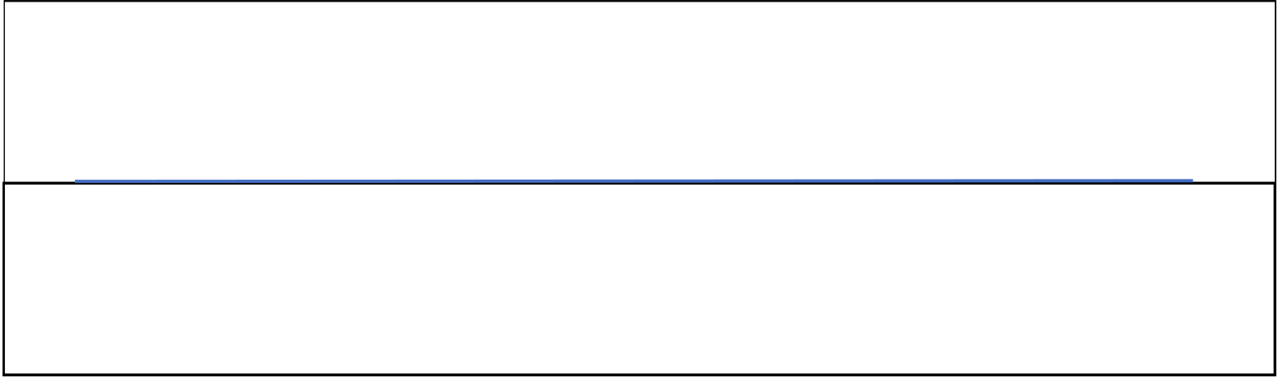 **CS23331 Design and Analysis of Algorithms**

Laboratory Record Note Book

|  |  |  |  |  |  |  |  |  |
| --- | --- | --- | --- | --- | --- | --- | --- | --- |
| Name :  Year / Branch / Section :   |  |  |  |  | | --- | --- | --- | --- | | University Register No.: |  |  | . | | College Roll No. : | . | | Semester : | | Academic Year : | |

|  |  |
| --- | --- |
|  | RAJALAKSHMI ENGINEERING COLLEGE  An Autonomous Institution |

|  |
| --- |
| BONAFIDE CERTIFICATE |

|  |  |
| --- | --- |
| Name: | …………………………………………………………………………… |

Academic Year: …………… Semester: …………… Branch: ………………

|  |  |  |
| --- | --- | --- |
| Register No. | |  | | --- | |  | |

Certified that this is the bonafide record of work done by the above student in

the..........................................................................................................Laboratory

during the academic year 2025- 2026

Signature of Faculty in-charge

Submitted for the Practical Examination held on……………………………  
  
  
  
  
  
  
Internal Examiner External Examiner

INDEX

|  |  |  |  |
| --- | --- | --- | --- |
| EX.NO | DATE | NAME OF THE EXPERIMENT | GITHUB QR |
| 1 |  | Basic C Programming |  |
| 2 |  | Time Complexity |
| 3 |  | Brute Force |
| 4 |  | Divide and Conquer |
| 5 |  | Greedy Technique |
| 6 |  | Dynamic Programming |



[**N**](http://118.185.187.137/moodle/user/view.php?id=10575&course=187)

[**2**](http://118.185.187.137/moodle/user/view.php?id=10575&course=187)



6

**Started on**

Friday, 8 August 2025, 1:47 PM

**State**

Finished

**Completed on**

Friday, 8 August 2025, 1:51 PM

**Time taken**

4

mins 13 secs

**Marks**

1.00/1.00

**Grade**

**10.00**

out of 10.00 (

**100**

%)

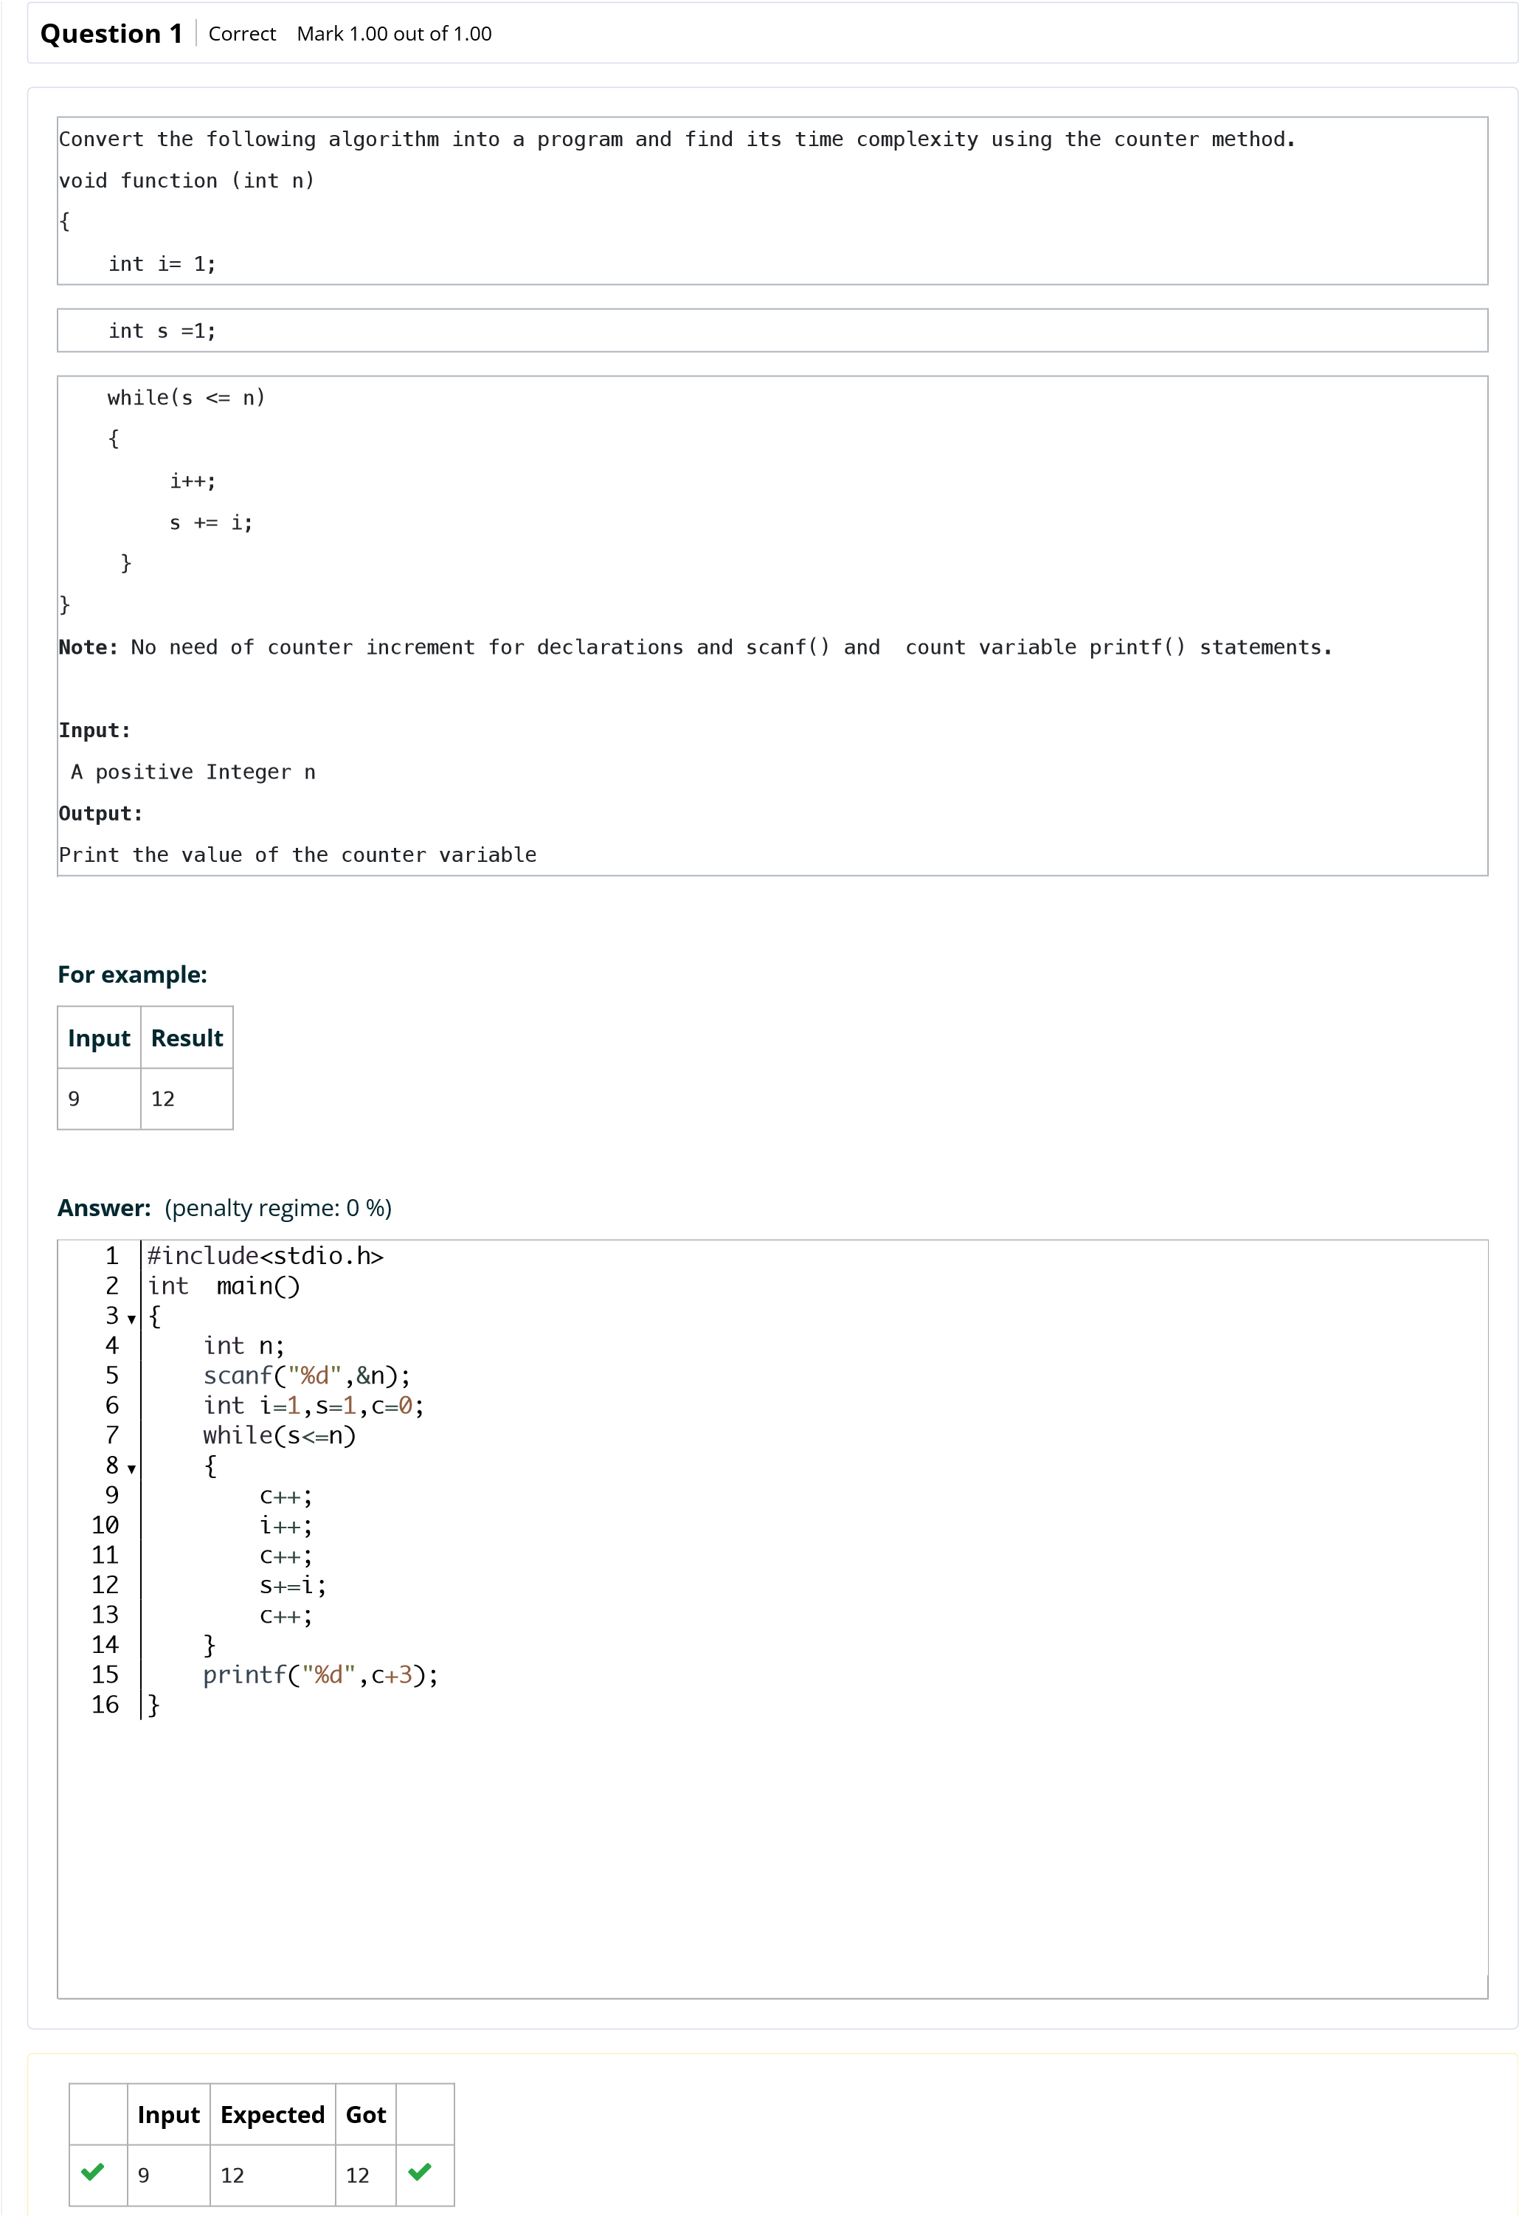

[e](http://118.185.187.137/moodle/course/view.php?id=187)

Back to Cour

[s](http://118.185.187.137/moodle/course/view.php?id=187)

**Input**

**Expected**

**Got**



4

9

9



Passed all tests!



**Correct**

Marks for this submission: 1.00/1.00.



**N2**



6

**Started on**

Friday, 8 August 2025, 1:32 PM

**State**

Finished

**Completed on**

Friday, 8 August 2025, 1:45 PM

**Time taken**

12

mins 42 secs

**Marks**

1.00/1.00

**Grade**

**10.00**

out of 10.00 (

**100**

%)

**Question**

**1**

Correct

Mark 1.00 out of 1.00

Convert the following algorithm into a program and find its time complexity using the counter method.

void func(int n)

{

if(n==1)

{

printf("*");

}

else

{

for(int i=1; i<=n; i++)

{

for(int j=1; j<=n; j++)

{

printf("*");

printf("*");

break;

}

}

}

}

**Note:**

No need of counter increment for declarations and scanf() and

count variable printf() statements.

**Input:**

A positive Integer n

**Output:**

Print the value of the counter variable

**Answer:**

)

penalty regime: 0 %

(

#include

stdio.h

<

>

void

func

(

int

n

)

{

int

c

=

0

;

if

(

n

==

1

)

{

printf

(

"

*

"

)

;

c

++

;

printf

(

"

*

"

)

;

c

++

;

printf

(

"

*

"

)

;

c

++

;

}

else

{

for

(

int

i

=

1

;

i

<

5

*

n

;

i

++

)

{

c

++

;

}

c

+=

2

;

}

printf

(

"

%d\n

"

,

c

+1

)

;

}

int

main

(

)

{

int

n

;

scanf

(

"

%d\n

"

,

&

n

)

;

func

(

n

)

;



1

2

3

▼

4

5

6

▼

7

8

9

10

11

12

13

14

15

16

▼

17

18

▼

19

20

21

22

23

24

25

26

▼

27

28

29

[s](http://118.185.187.137/moodle/course/view.php?id=187)

[e](http://118.185.187.137/moodle/course/view.php?id=187)

Back to Cour

**Input**

**Expected**

**Got**



2

12

12





1000

5002

5002





143

717

717



Passed all tests!



**Correct**

Marks for this submission: 1.00/1.00.



**N2**



6

**Started on**

Friday, 8 August 2025, 1:45 PM

**State**

Finished

**Completed on**

Friday, 8 August 2025, 2:10 PM

**Time taken**

24

mins 26 secs

**Marks**

1.00/1.00

**Grade**

**10.00**

out of 10.00 (

**100**

%)

**Question**

**1**

Correct

Mark 1.00 out of 1.00

Convert the following algorithm into a program and find its time complexity using counter method.

Factor(num) {

{

for (i = 1; i <= num;++i)

{

if (num % i== 0)

{

printf("%d ", i);

}

}

}

**Note:**

No need of counter increment for declarations and scanf() and

counter variable printf() statement.

**Input:**

A positive Integer n

**Output:**

Print the value of the counter variable

**Answer:**

#include

stdio.h

<

>

int

main

(

)

{

int

n

,

c

=

0

,

j

;

scanf

(

"

%d

"

,

&

n

)

;

for

(

int

i

=

1

;

i

<=

n

;

i

++

)

{

if

(

n

%

i

==

0

)

{

c

++

;

}

}

j

=

(

n

*

2

)

+

c

;

printf

(

"

%d

"

,

j

+1

)

;

}



1

2

3

▼

4

5

6

7

▼

8

9

▼

10

11

12

13

14

15

[s](http://118.185.187.137/moodle/course/view.php?id=187)

[e](http://118.185.187.137/moodle/course/view.php?id=187)

Back to Cour

**Input**

**Expected**

**Got**



12

31

31





25

54

54





4

12

12



Passed all tests!



**Correct**

Marks for this submission: 1.00/1.00.



**N2**



6

**Started on**

Friday, 8 August 2025, 2:10 PM

**State**

Finished

**Completed on**

Friday, 8 August 2025, 2:25 PM

**Time taken**

14

mins 46 secs

**Marks**

1.00/1.00

**Grade**

**10.00**

out of 10.00 (

**100**

%)

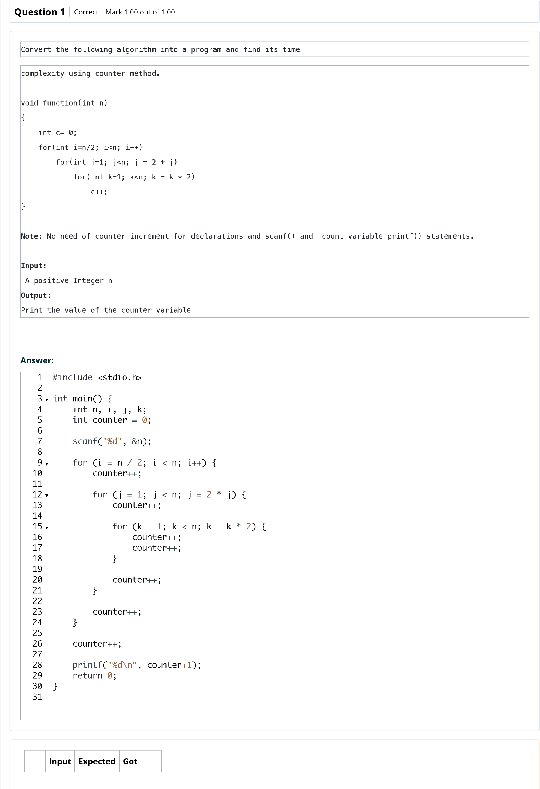

[e](http://118.185.187.137/moodle/course/view.php?id=187)

Back to Cour

[s](http://118.185.187.137/moodle/course/view.php?id=187)

**Input**

**Expected**

**Got**



4

30

30





10

212

212



Passed all tests!



**Correct**

Marks for this submission: 1.00/1.00.



**N2**



6

**Started on**

Friday, 8 August 2025, 2:25 PM

**State**

Finished

**Completed on**

Friday, 8 August 2025, 2:31 PM

**Time taken**

5

mins 35 secs

**Marks**

1.00/1.00

**Grade**

**10.00**

out of 10.00 (

**100**

%)

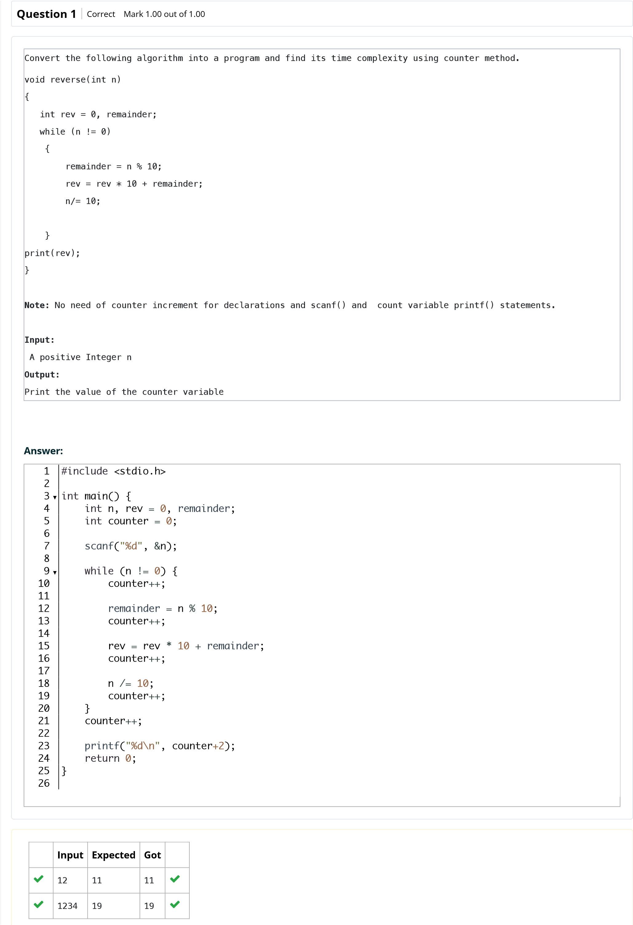

Back to Cour

[s](http://118.185.187.137/moodle/course/view.php?id=187)

[e](http://118.185.187.137/moodle/course/view.php?id=187)

Passed all tests!



**Correct**

Marks for this submission: 1.00/1.00.



**N2**



6

**Started on**

Friday, 19 September 2025, 1:44 PM

**State**

Finished

**Completed on**

Friday, 19 September 2025, 1:46 PM

**Time taken**

1

min 56 secs

**Marks**

1.00/1.00

**Grade**

**10.00**

out of 10.00 (

**100**

%)

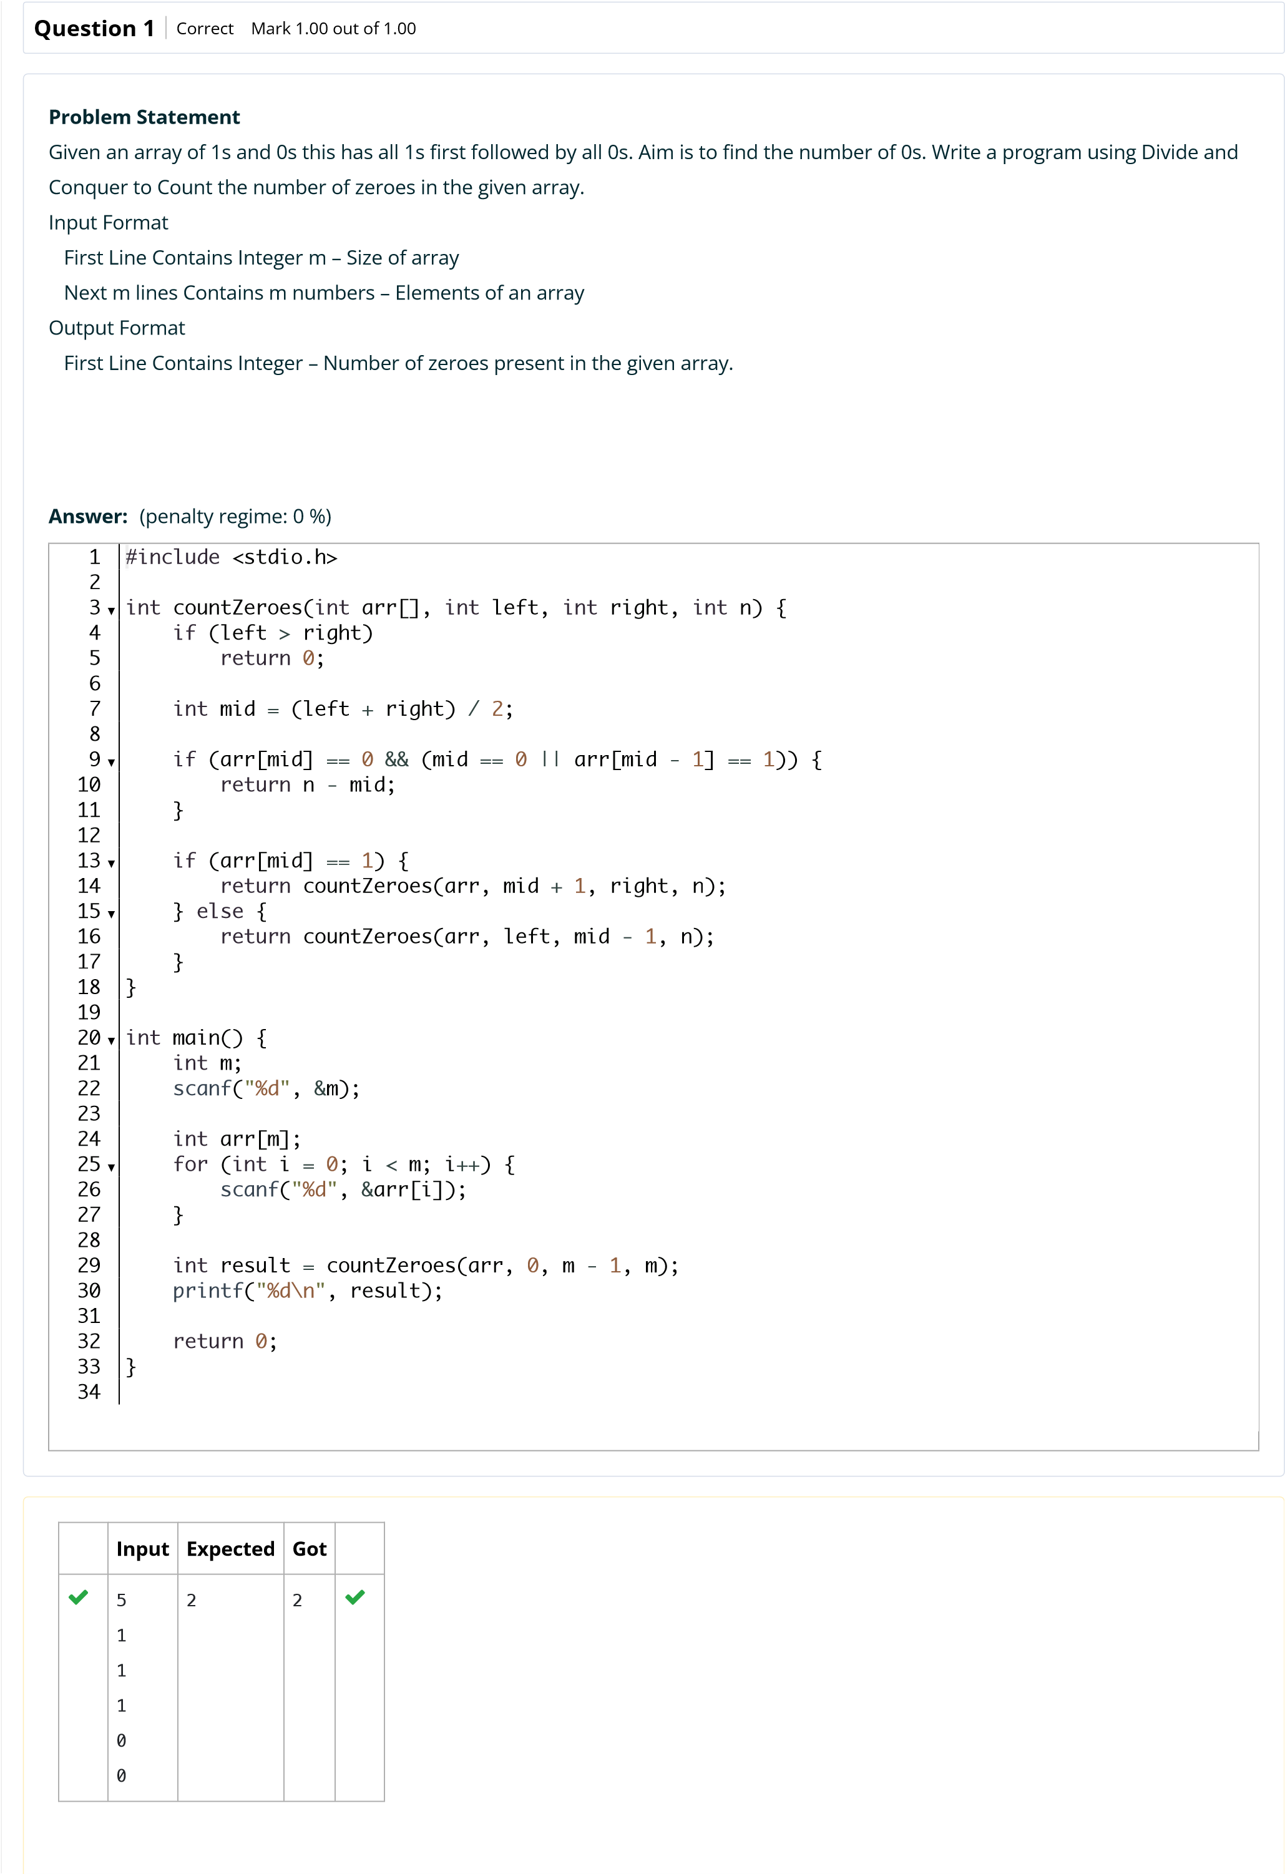

[s](http://118.185.187.137/moodle/course/view.php?id=187)

Back to Cour

[e](http://118.185.187.137/moodle/course/view.php?id=187)

**Input**

**Expected**

**Got**



10

1

1

1

1

1

1

1

1

1

1

0

0





8

0

0

0

0

0

0

0

0

8

8





17

1

1

1

1

1

1

1

1

1

1

1

1

1

1

1

0

0

2

2



Passed all tests!



**Correct**

Marks for this submission: 1.00/1.00.



**N2**



6

**Started on**

Friday, 19 September 2025, 1:46 PM

**State**

Finished

**Completed on**

Friday, 19 September 2025, 1:47 PM

**Time taken**

29

secs

**Marks**

1.00/1.00

**Grade**

**10.00**

out of 10.00 (

**100**

%)

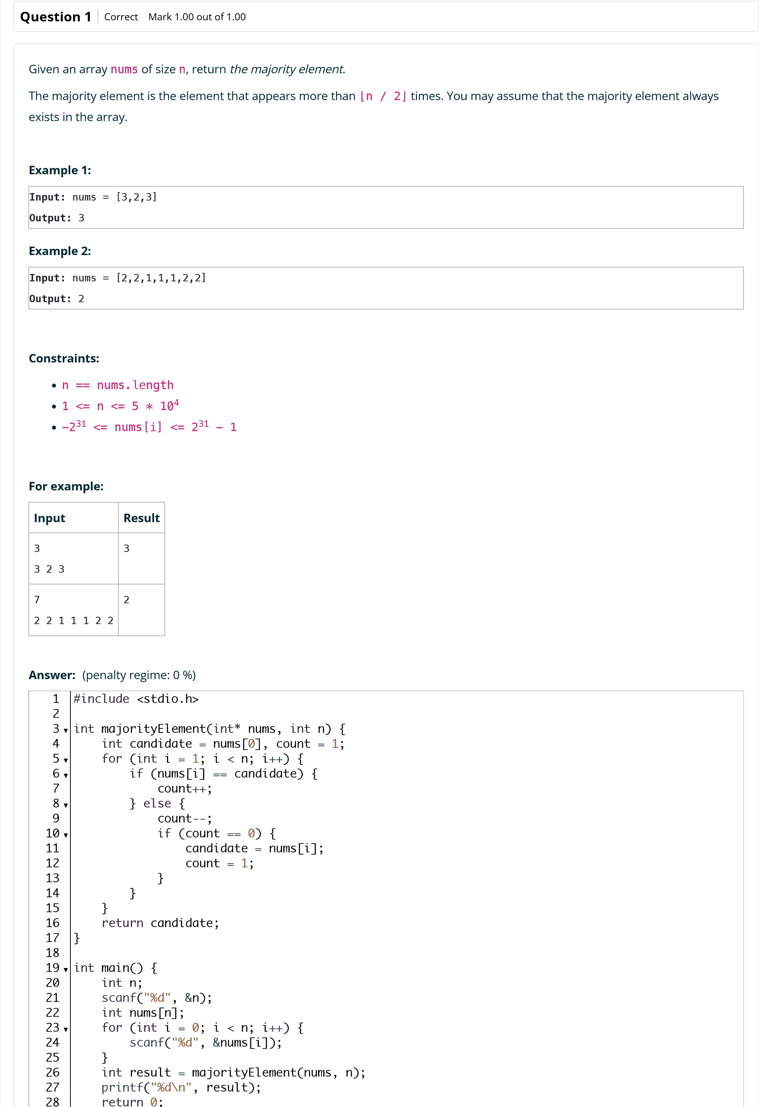

Back to Cour

[s](http://118.185.187.137/moodle/course/view.php?id=187)

[e](http://118.185.187.137/moodle/course/view.php?id=187)

**Input**

**Expected**

**Got**



3

3

2

3

3

3



Passed all tests!



**Correct**

Marks for this submission: 1.00/1.00.



**N2**



6

**Started on**

Friday, 19 September 2025, 1:47 PM

**State**

Finished

**Completed on**

Friday, 19 September 2025, 1:50 PM

**Time taken**

2

mins 47 secs

**Marks**

1.00/1.00

**Grade**

**10.00**

out of 10.00 (

**100**

%)

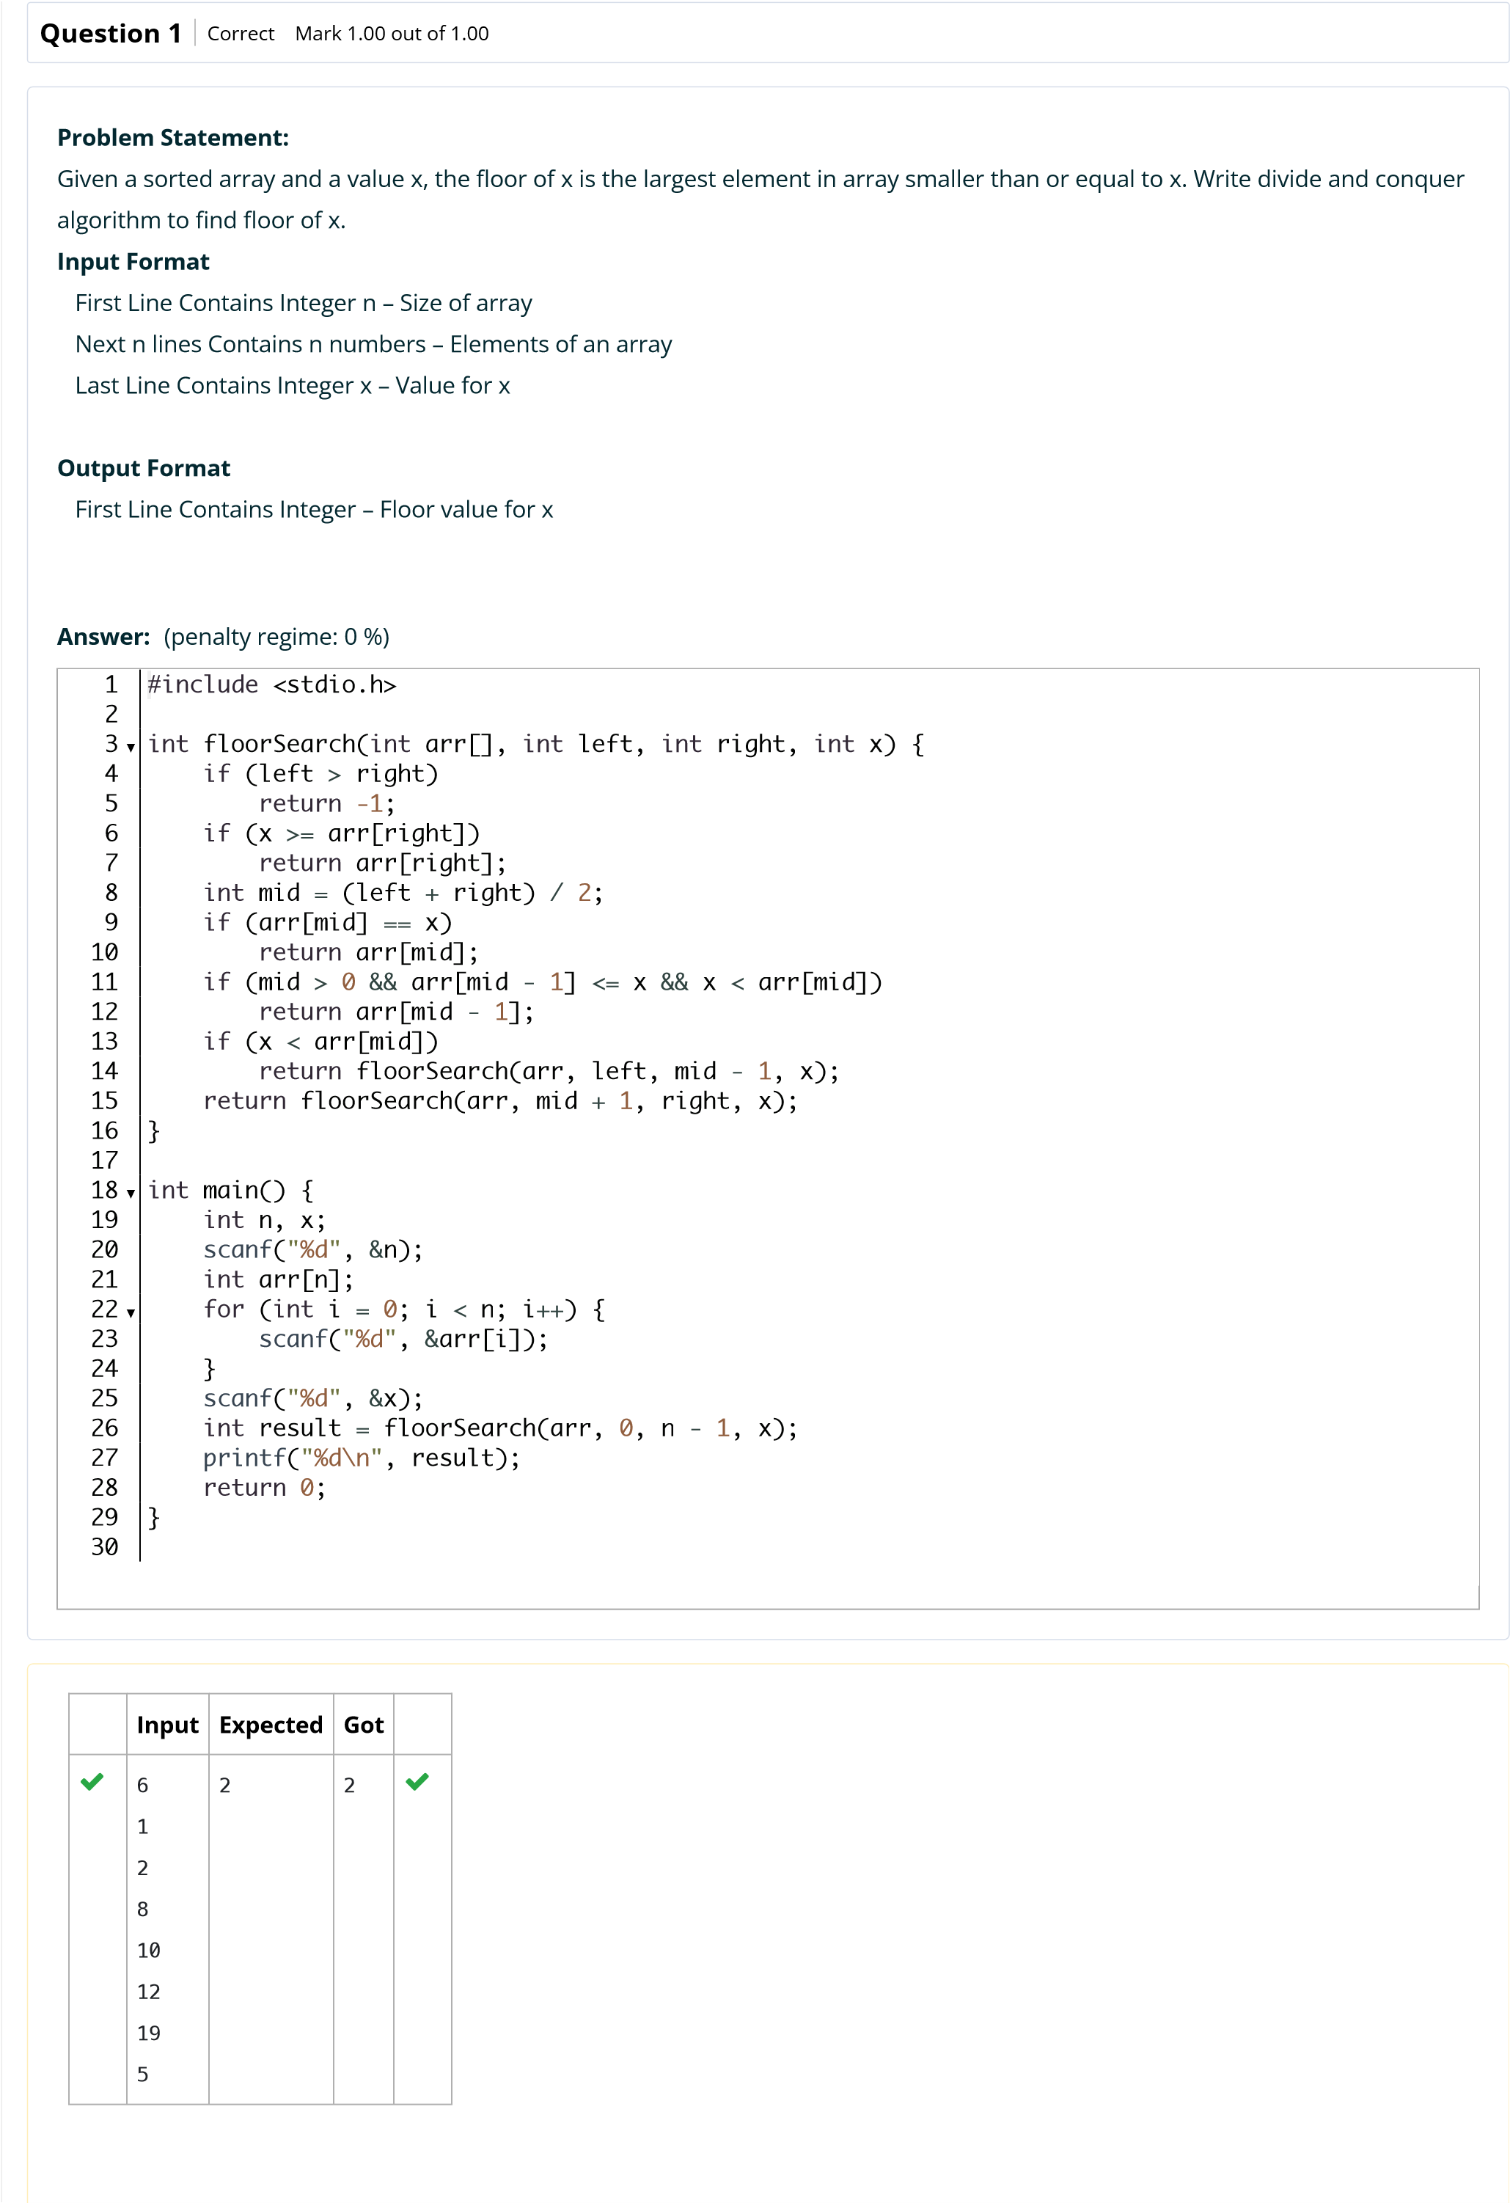

[s](http://118.185.187.137/moodle/course/view.php?id=187)

[e](http://118.185.187.137/moodle/course/view.php?id=187)

Back to Cour

**Input**

**Expected**

**Got**



5

10

22

85

108

129

100

85

85





7

3

5

7

9

11

13

15

10

9

9



Passed all tests!



**Correct**

Marks for this submission: 1.00/1.00.



**N2**



6

**Started on**

Friday, 19 September 2025, 1:50 PM

**State**

Finished

**Completed on**

Friday, 19 September 2025, 1:51 PM

**Time taken**

29

secs

**Marks**

1.00/1.00

**Grade**

**10.00**

out of 10.00 (

**100**

%)

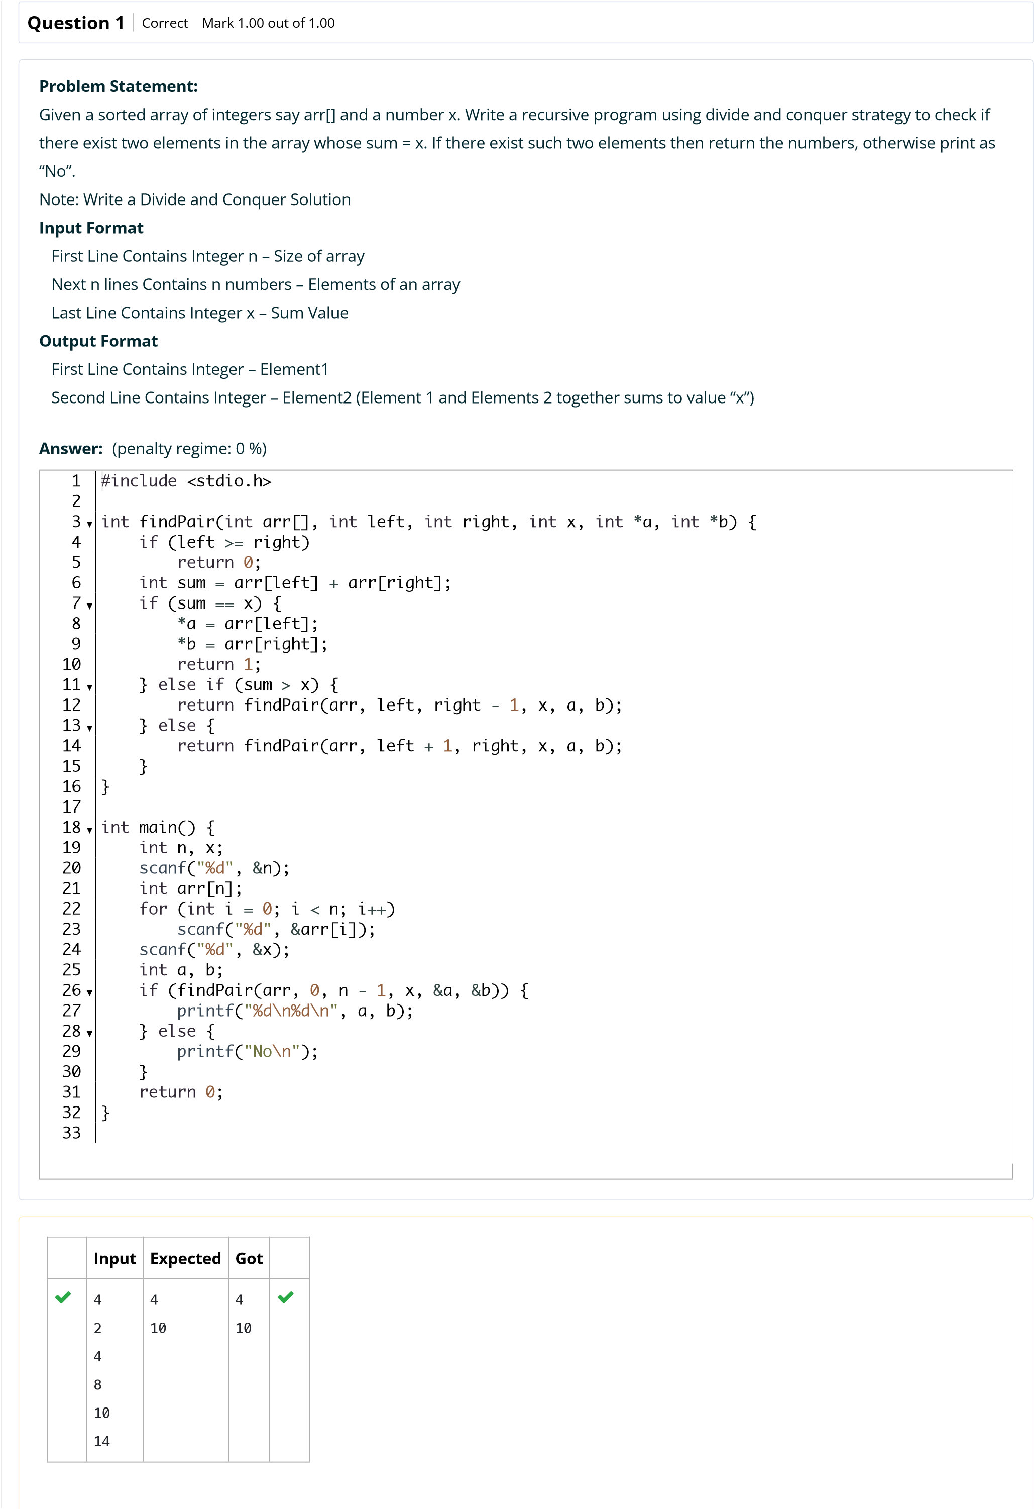

[e](http://118.185.187.137/moodle/course/view.php?id=187)

Back to Cour

[s](http://118.185.187.137/moodle/course/view.php?id=187)

**Input**

**Expected**

**Got**



5

2

4

6

8

10

100

No

No



Passed all tests!



**Correct**

Marks for this submission: 1.00/1.00.



**N2**



6

**Started on**

Friday, 19 September 2025, 1:51 PM

**State**

Finished

**Completed on**

Friday, 19 September 2025, 1:51 PM

**Time taken**

31

secs

**Marks**

1.00/1.00

**Grade**

**10.00**

out of 10.00 (

**100**

%)

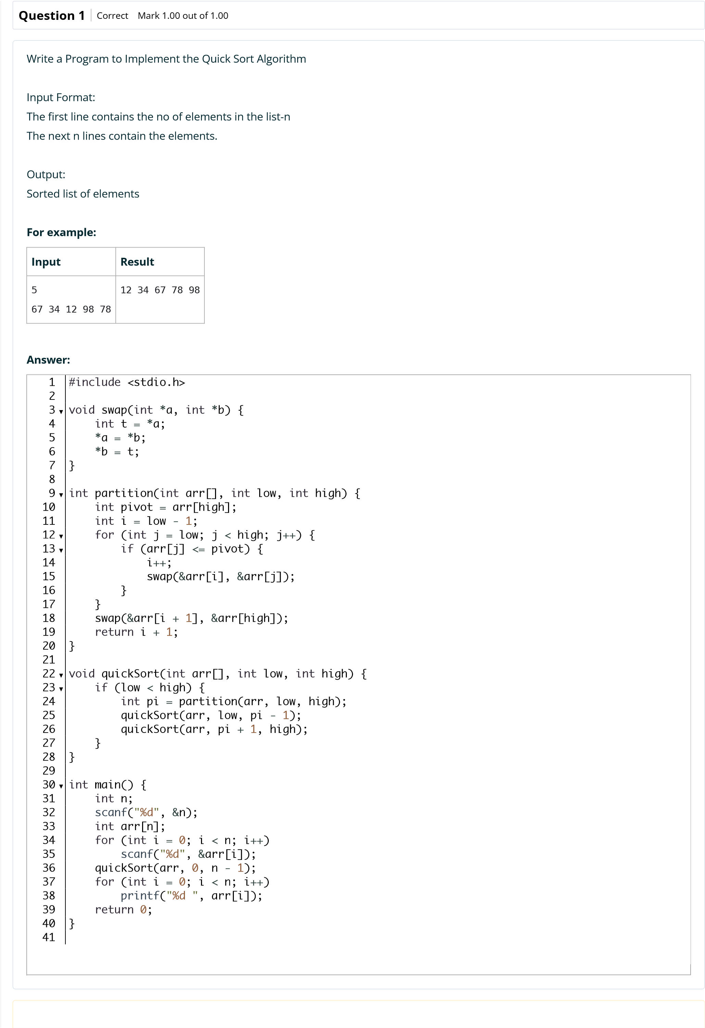

[s](http://118.185.187.137/moodle/course/view.php?id=187)

[e](http://118.185.187.137/moodle/course/view.php?id=187)

Back to Cour

**Input**

**Expected**

**Got**



5

67

34 12 98

78

34 67 78

98

12

34 67 78

12

98





10

1

56 78 90 32 56 11 10

90 114

1

10 11 32 56 56 78 90

90 114

1

10 11 32 56 56 78 90

90 114





12

9

8 7 6 5 4 3 2 1 10 11

90

2 3 4 5 6 7 8 9 10 11

1

90

1

2 3 4 5 6 7 8 9 10 11

90



Passed all tests!



**Correct**

Marks for this submission: 1.00/1.00.



**N2**



6

**Started on**

Sunday, 24 August 2025, 6:43 PM

**State**

Finished

**Completed on**

Sunday, 24 August 2025, 6:44 PM

**Time taken**

1

min 12 secs

**Marks**

1.00/1.00

**Grade**

**10.00**

out of 10.00 (

**100**

%)

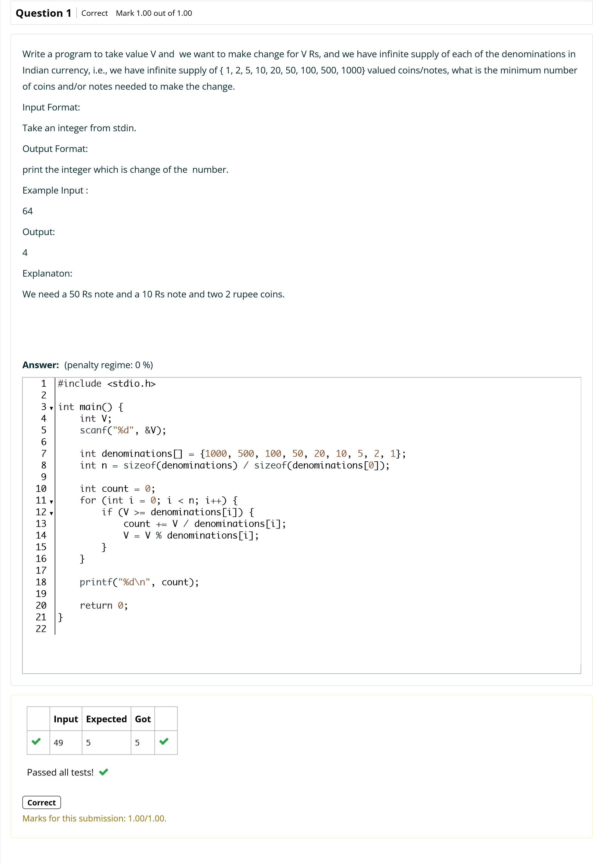

Back to Cour

[s](http://118.185.187.137/moodle/course/view.php?id=187)

[e](http://118.185.187.137/moodle/course/view.php?id=187)



**N2**



6

**Started on**

Sunday, 24 August 2025, 6:44 PM

**State**

Finished

**Completed on**

Sunday, 24 August 2025, 6:46 PM

**Time taken**

1

min 10 secs

**Marks**

1.00/1.00

**Grade**

**10.00**

out of 10.00 (

**100**

%)

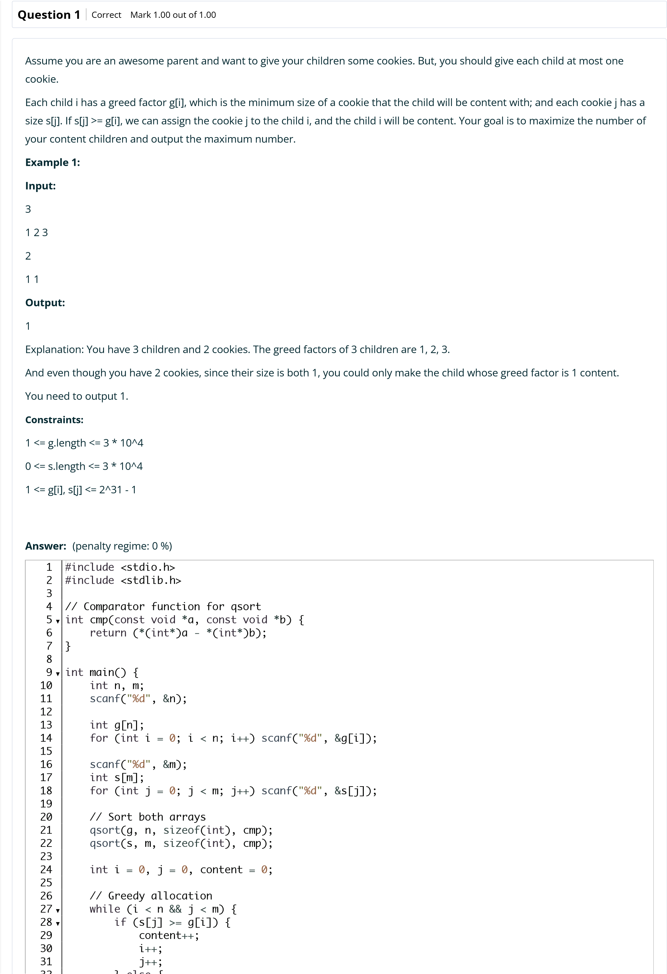

[e](http://118.185.187.137/moodle/course/view.php?id=187)

Back to Cour

[s](http://118.185.187.137/moodle/course/view.php?id=187)

**Input**

**Expected**

**Got**



2

1

2

3

1

2

3

2

2



Passed all tests!



**Correct**

Marks for this submission: 1.00/1.00.



**N2**



6

**Started on**

Sunday, 31 August 2025, 11:23 AM

**State**

Finished

**Completed on**

Sunday, 31 August 2025, 11:41 AM

**Time taken**

17

mins 48 secs

**Marks**

1.00/1.00

**Grade**

**10.00**

out of 10.00 (

**100**

%)

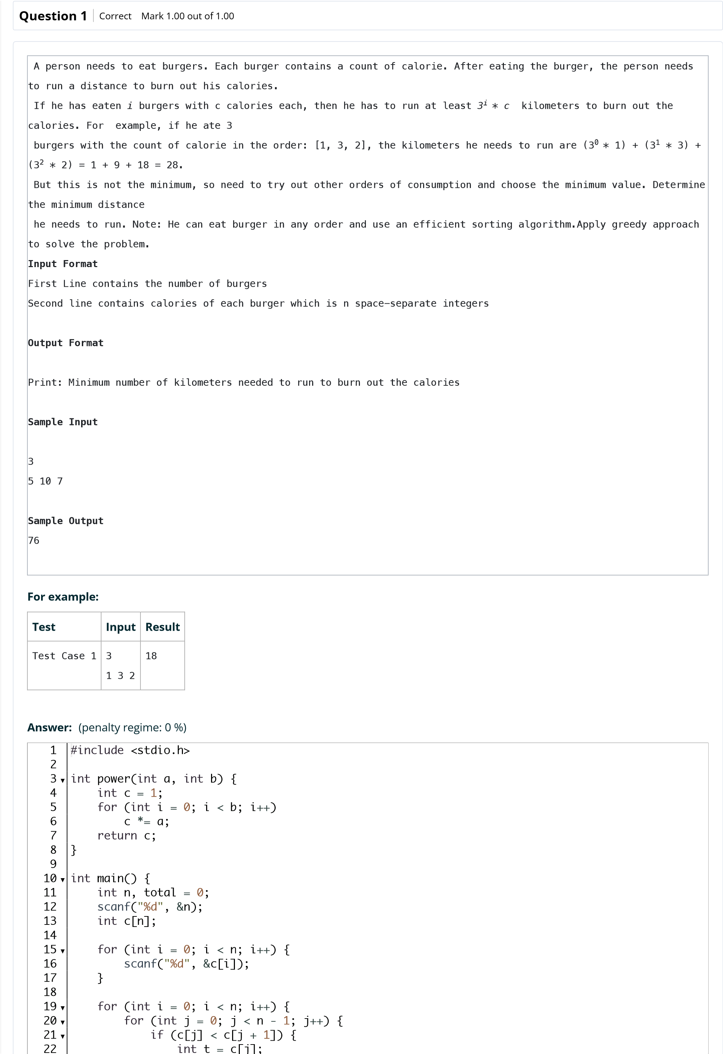

[s](http://118.185.187.137/moodle/course/view.php?id=187)

[e](http://118.185.187.137/moodle/course/view.php?id=187)

Back to Cour

**Test**

**Input**

**Expected**

**Got**



Test Case 1

3

2

1

3

18

18





Test Case 2

4

7

4 9

6

389

389





Test Case 3

3

5

10

7

76

76



Passed all tests!



**Correct**

Marks for this submission: 1.00/1.00.



**N2**



6

**Started on**

Sunday, 24 August 2025, 6:48 PM

**State**

Finished

**Completed on**

Sunday, 24 August 2025, 6:48 PM

**Time taken**

46

secs

**Marks**

1.00/1.00

**Grade**

**10.00**

out of 10.00 (

**100**

%)

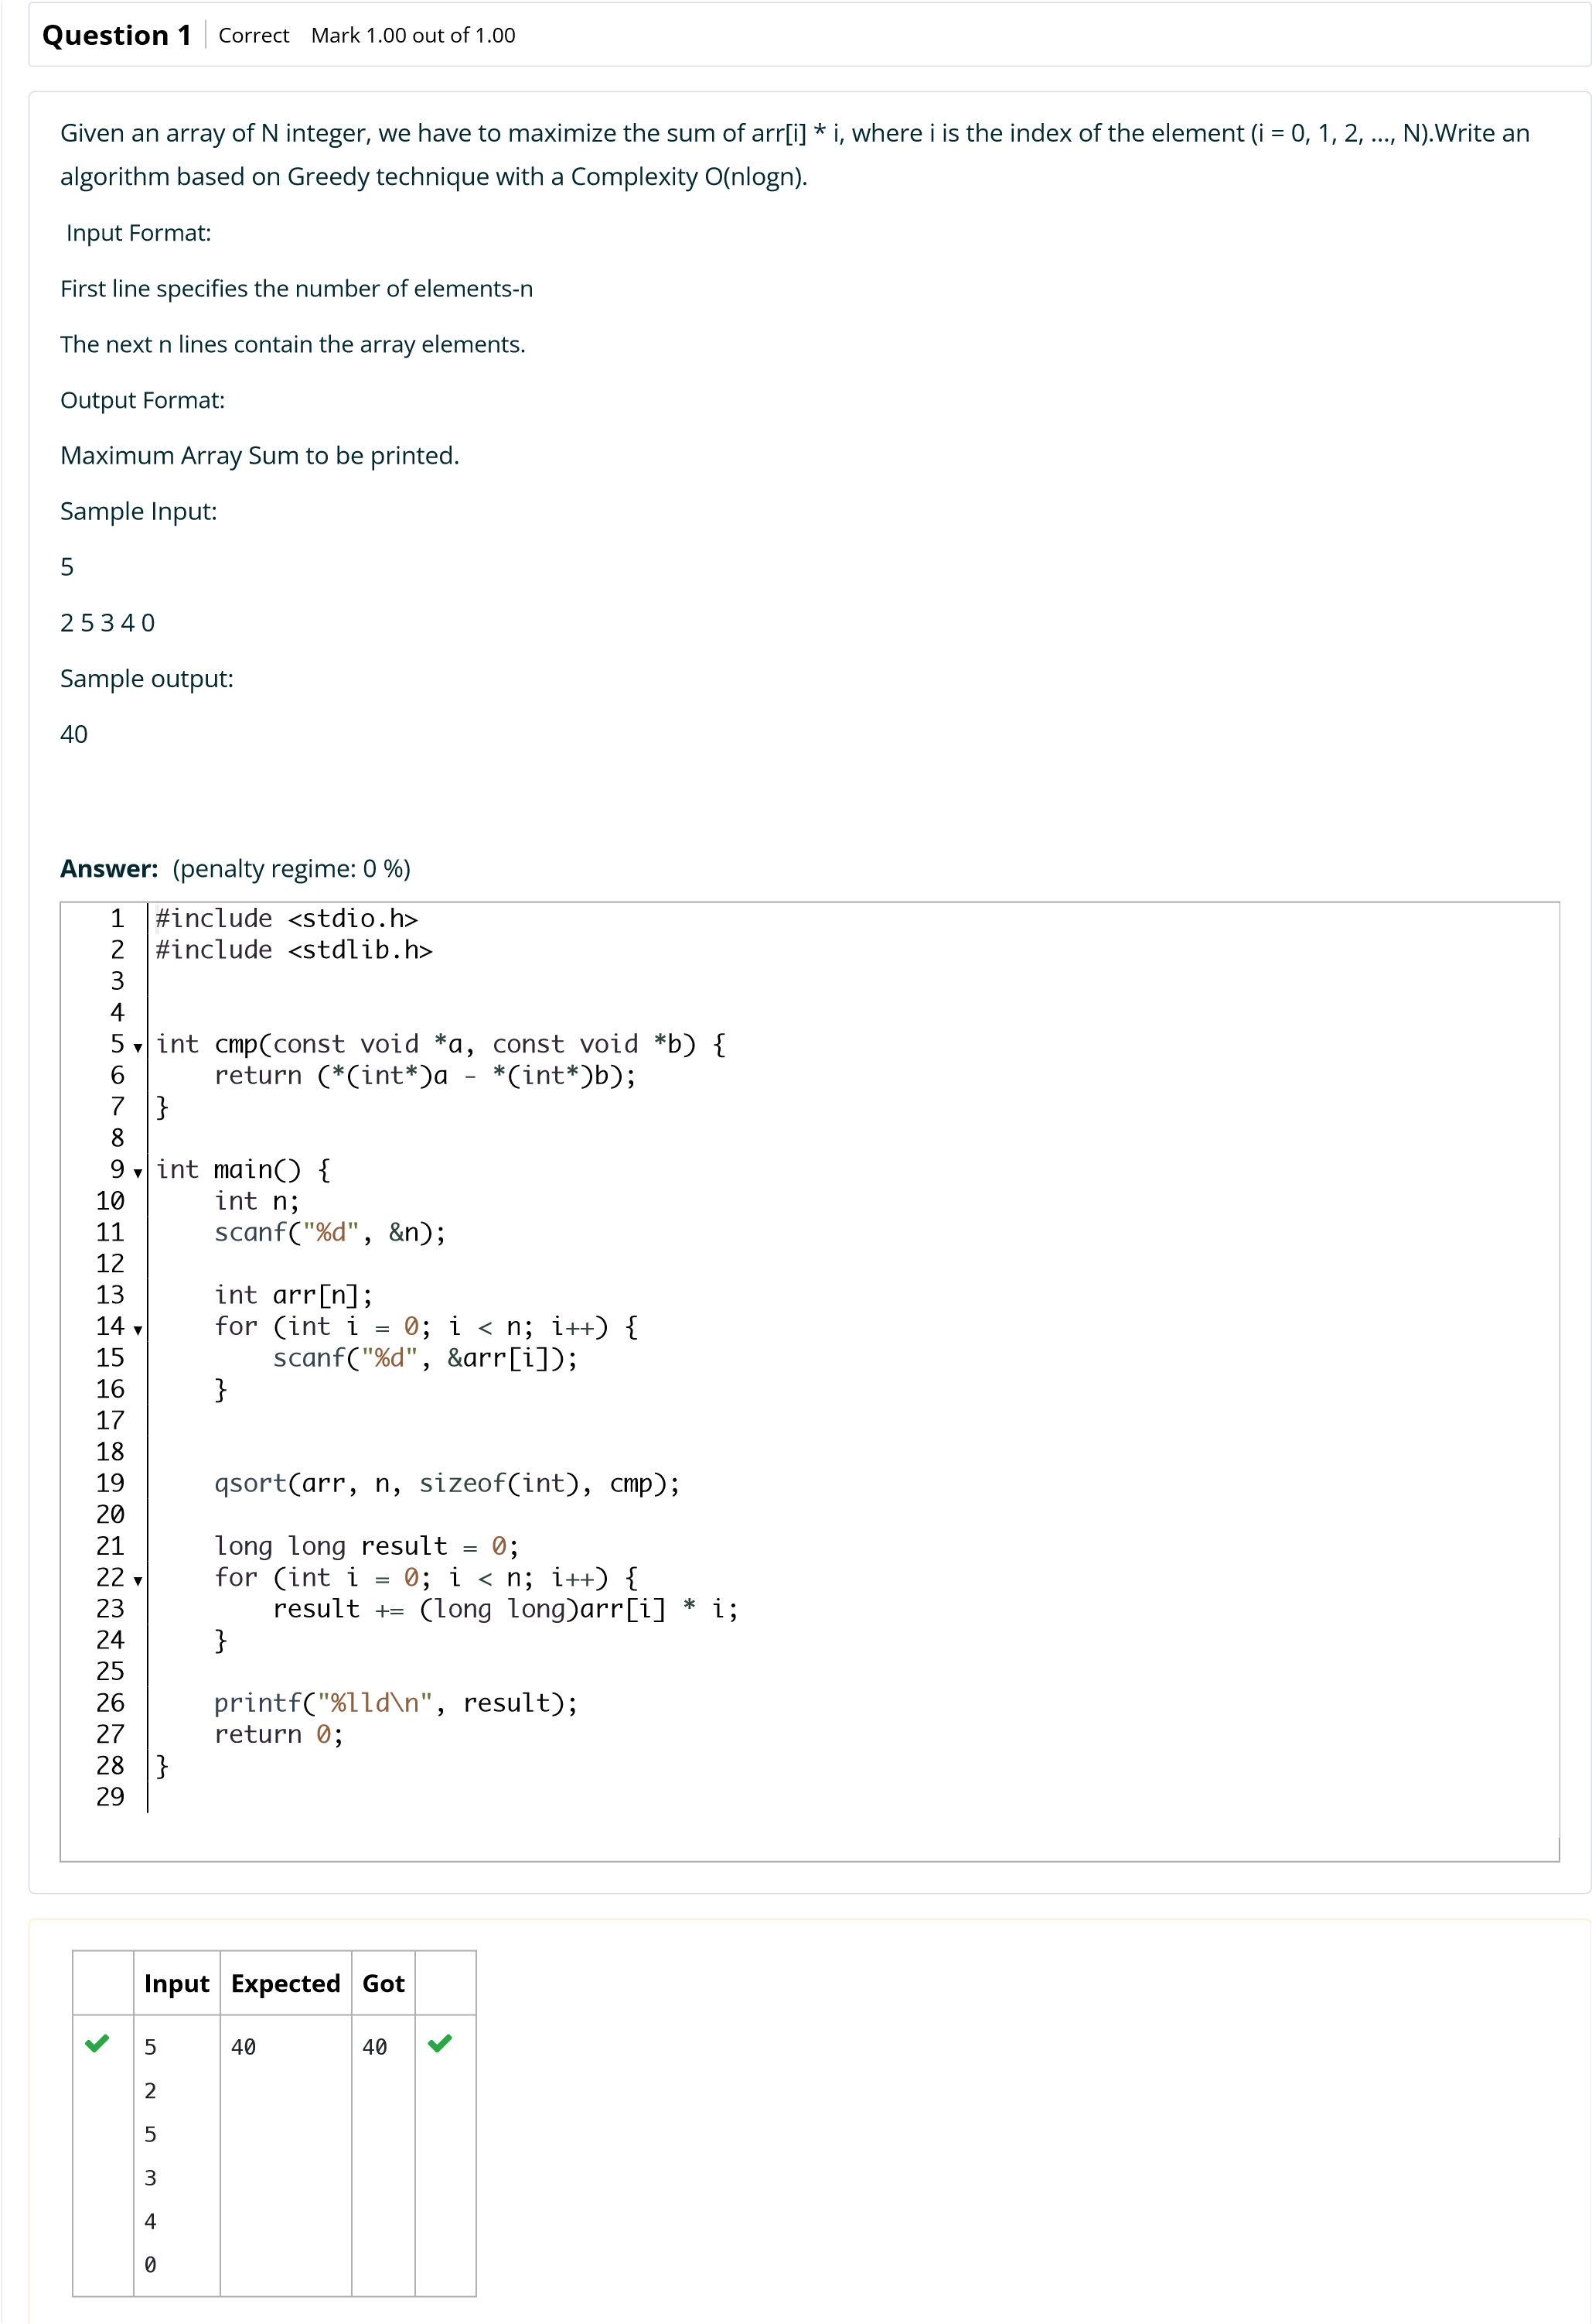

[e](http://118.185.187.137/moodle/course/view.php?id=187)

Back to Cour

[s](http://118.185.187.137/moodle/course/view.php?id=187)

**Input**

**Expected**

**Got**



10

2

2

2

4

4

3

3

5

5

5

191

191





2

45

3

45

45



Passed all tests!



**Correct**

Marks for this submission: 1.00/1.00.



**N2**



6

**Started on**

Sunday, 24 August 2025, 6:49 PM

**State**

Finished

**Completed on**

Sunday, 24 August 2025, 6:49 PM

**Time taken**

46

secs

**Marks**

1.00/1.00

**Grade**

**10.00**

out of 10.00 (

**100**

%)

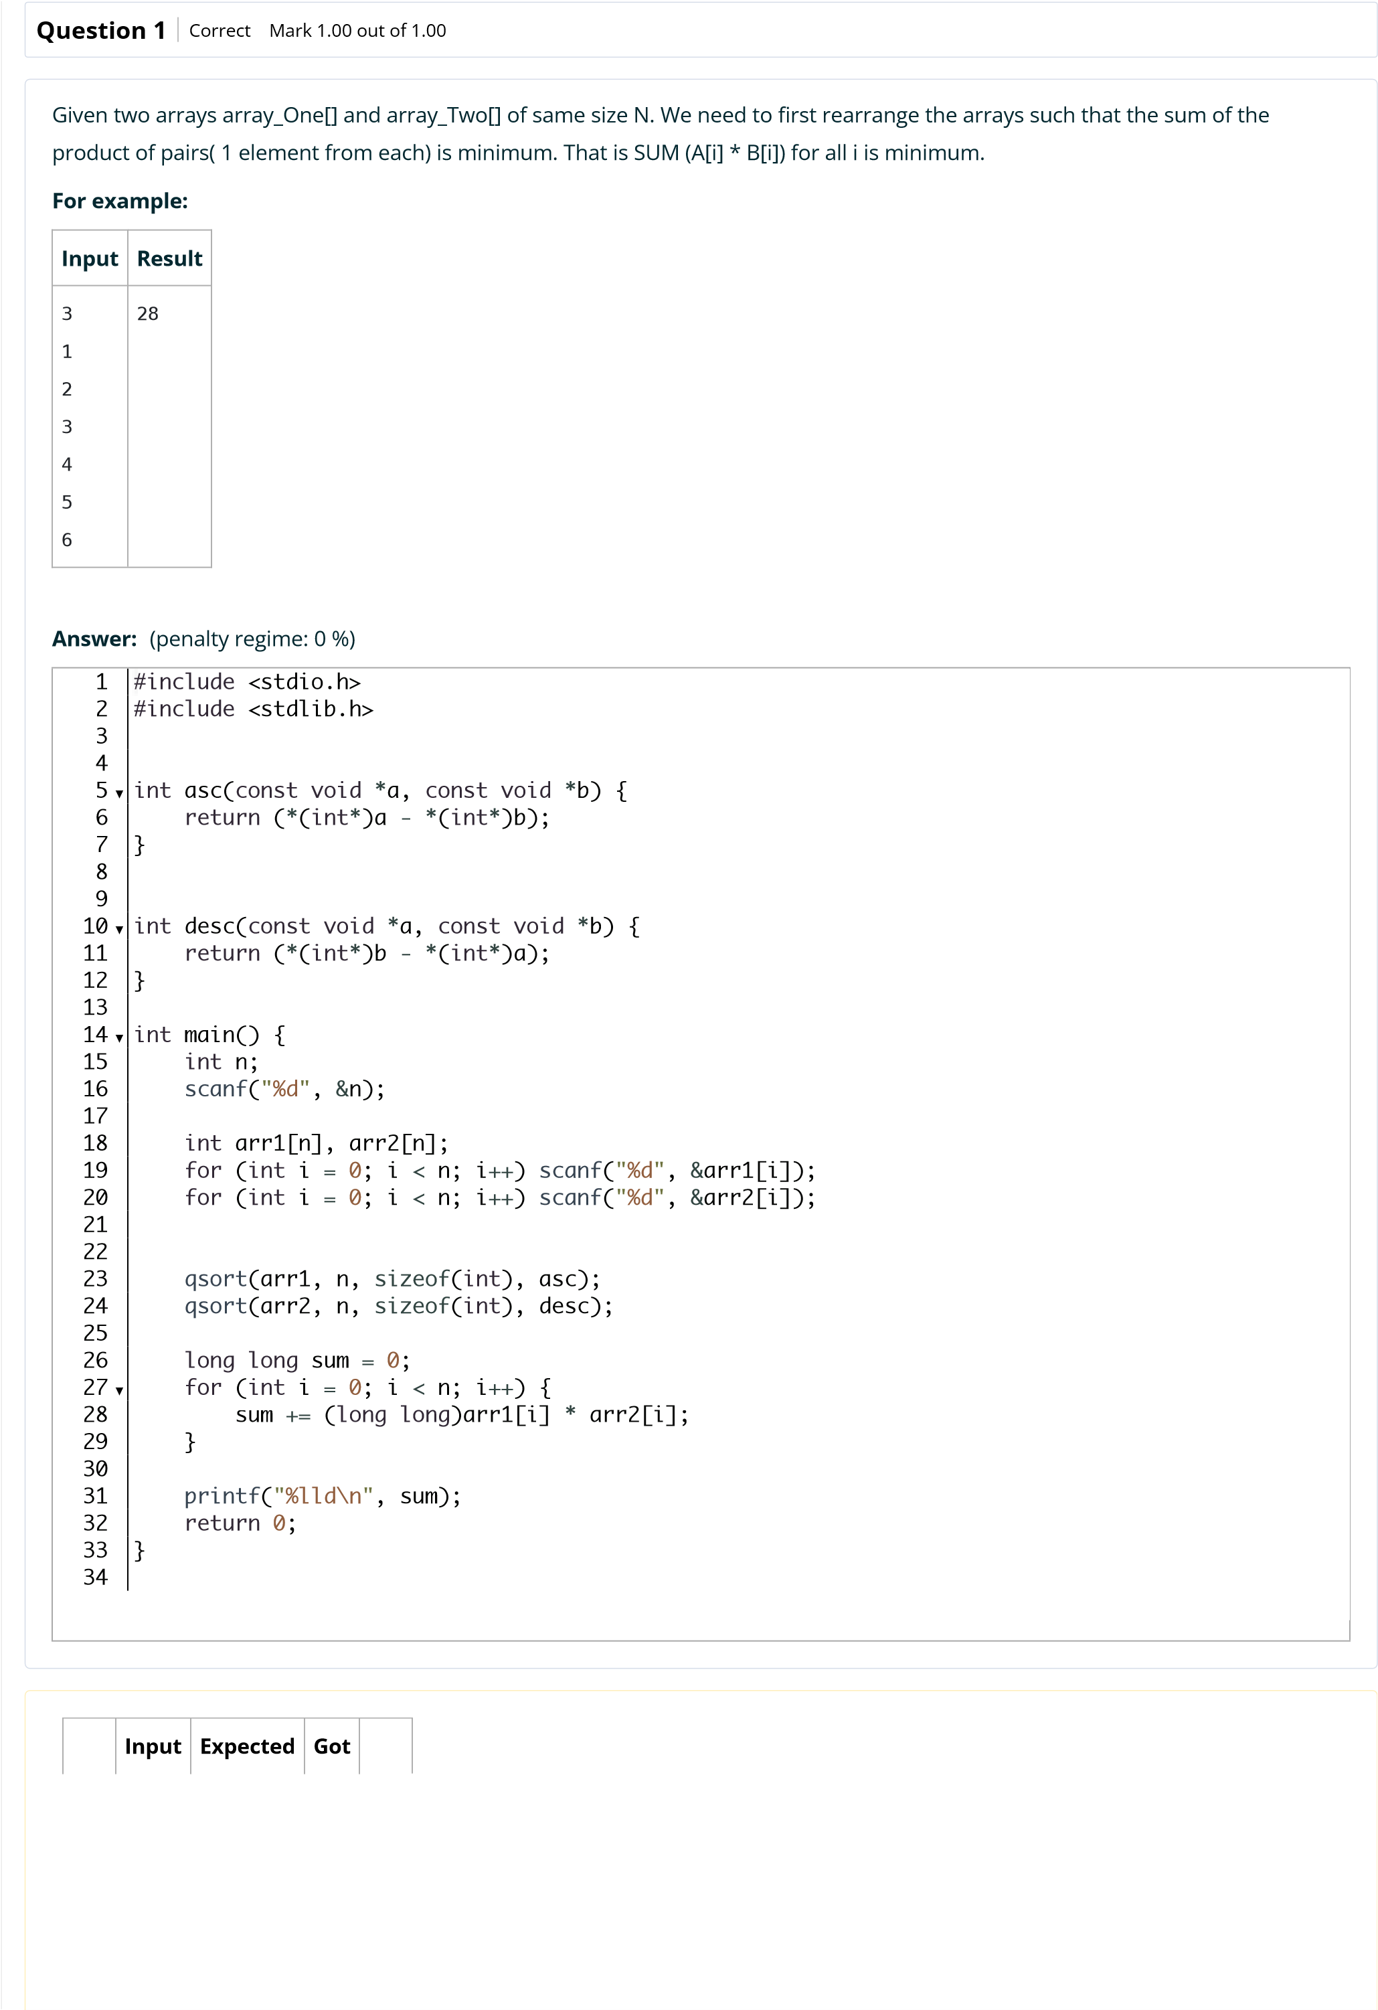

[e](http://118.185.187.137/moodle/course/view.php?id=187)

Back to Cour

[s](http://118.185.187.137/moodle/course/view.php?id=187)

**Input**

**Expected**

**Got**



3

1

2

3

4

5

6

28

28





4

7

5

1

2

1

3

4

1

22

22





5

20

10

30

10

40

8

9

4

3

10

590

590



Passed all tests!



**Correct**

Marks for this submission: 1.00/1.00.



**N2**



6

**Started on**

Sunday, 12 October 2025, 11:17 AM

**State**

Finished

**Completed on**

Sunday, 12 October 2025, 11:19 AM

**Time taken**

1

min 36 secs

**Grade**

**10.00**

out of 10.00 (

**100**

%)

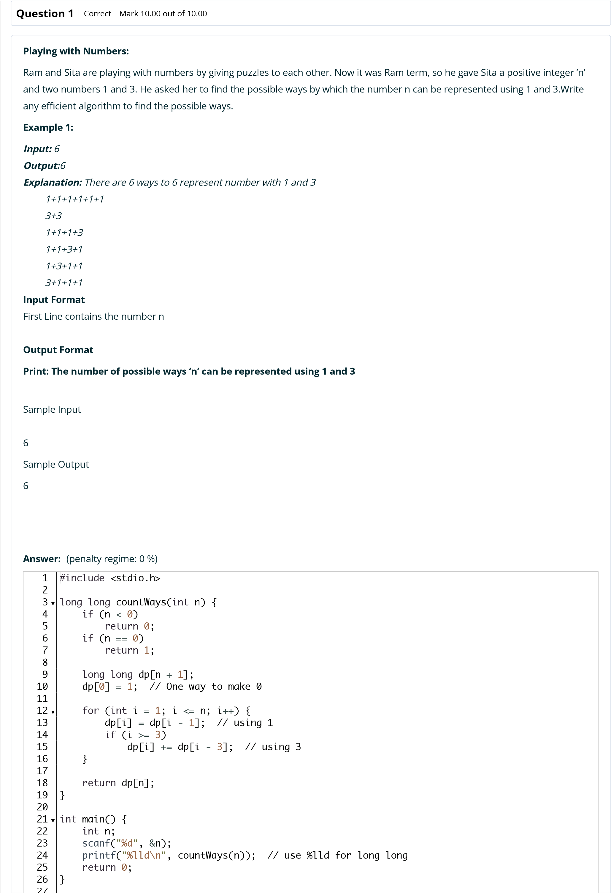

[s](http://118.185.187.137/moodle/course/view.php?id=187)

[e](http://118.185.187.137/moodle/course/view.php?id=187)

Back to Cour

**Input**

**Expected**

**Got**



6

6

6





25

8641

8641





100

24382819596721629

24382819596721629



Passed all tests!



**Correct**

Marks for this submission: 10.00/10.00.



**N2**



6

**Started on**

Sunday, 12 October 2025, 11:19 AM

**State**

Finished

**Completed on**

Sunday, 12 October 2025, 11:20 AM

**Time taken**

53

secs

**Grade**

**10.00**

out of 10.00 (

**100**

%)

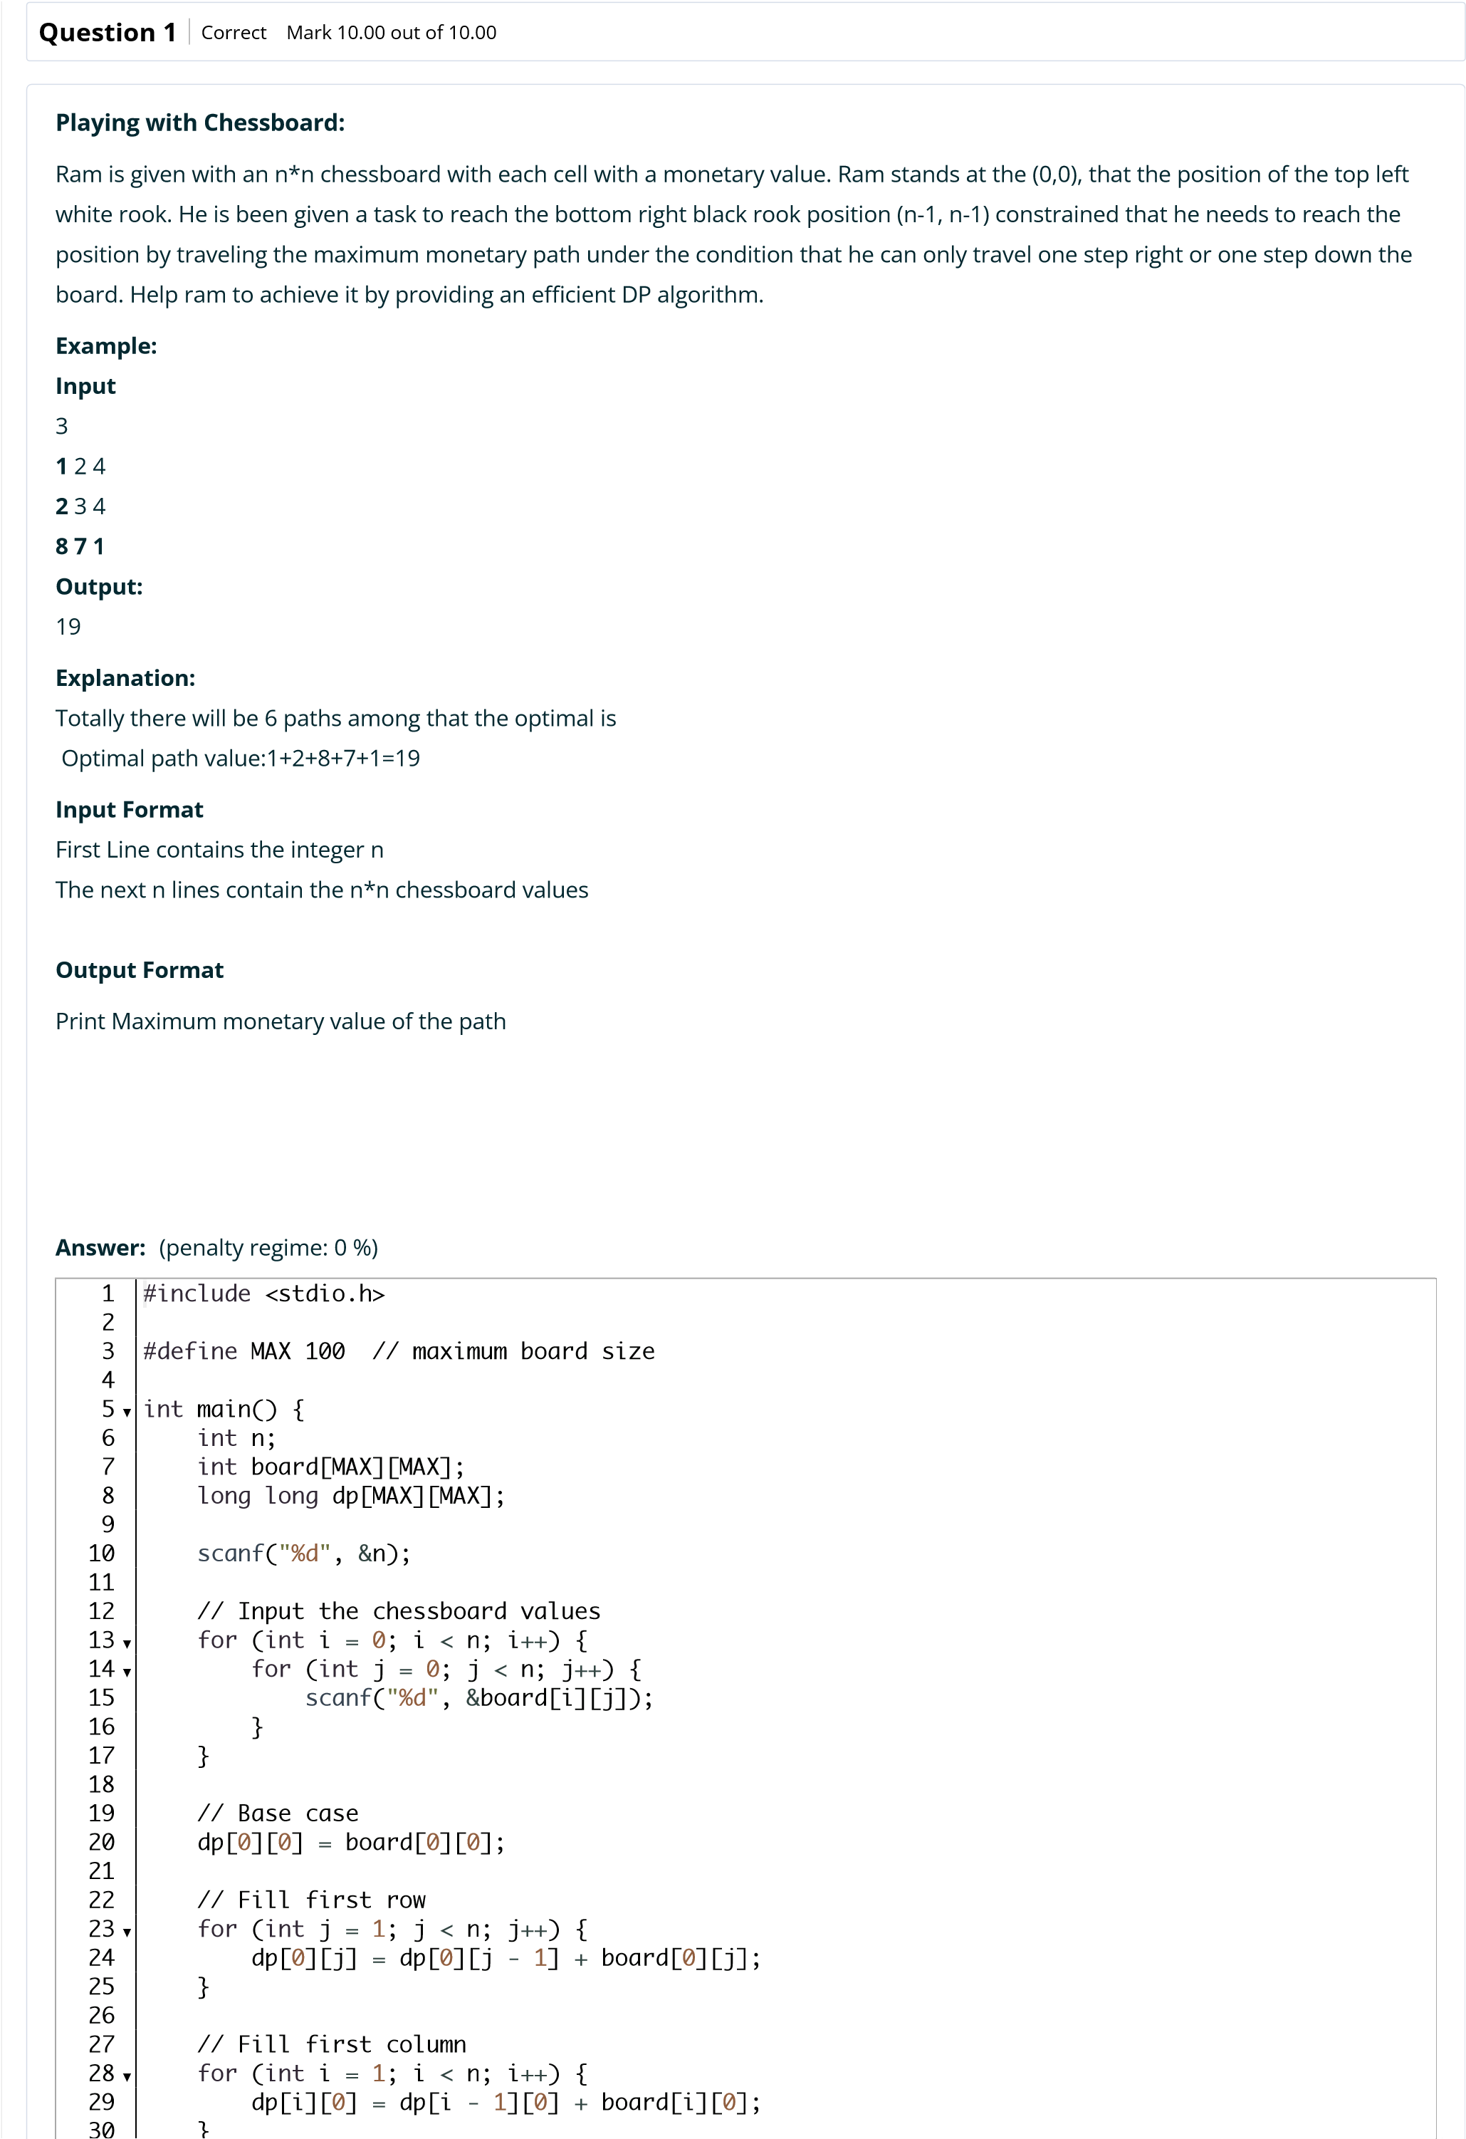

Back to Cour

[s](http://118.185.187.137/moodle/course/view.php?id=187)

[e](http://118.185.187.137/moodle/course/view.php?id=187)

**Input**

**Expected**

**Got**



3

1

2

4

3

2

4

1

8

7

19

19





3

1

3

1

1

5

1

4

2

1

12

12





4

4

1

1 3

1

5 7

8

2

3 4

6

6 9

0

1

28

28



Passed all tests!



**Correct**

Marks for this submission: 10.00/10.00.



**N2**



6

**Started on**

Sunday, 12 October 2025, 11:20 AM

**State**

Finished

**Completed on**

Sunday, 12 October 2025, 11:21 AM

**Time taken**

52

secs

**Marks**

1.00/1.00

**Grade**

**10.00**

out of 10.00 (

**100**

%)

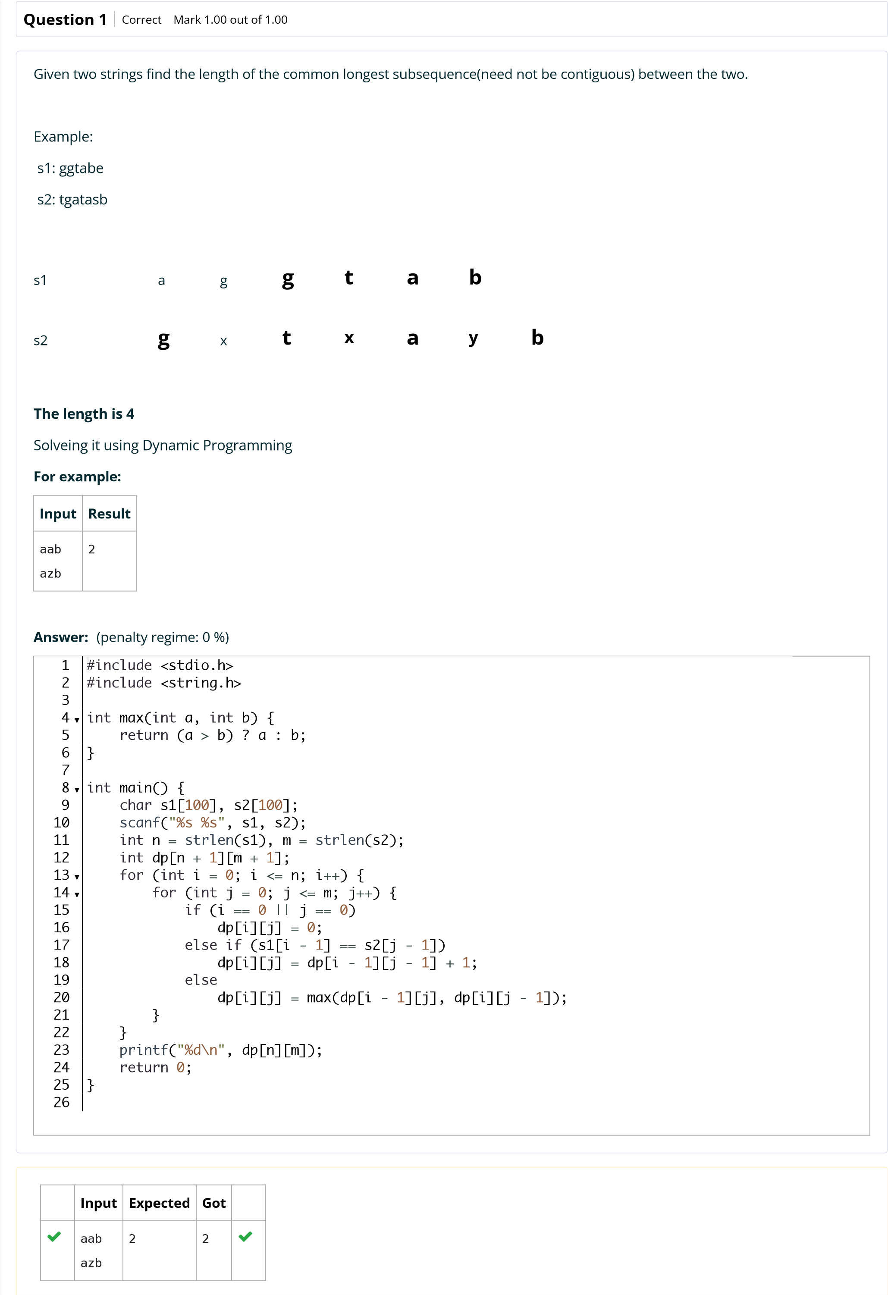

[e](http://118.185.187.137/moodle/course/view.php?id=187)

Back to Cour

[s](http://118.185.187.137/moodle/course/view.php?id=187)

**Input**

**Expected**

**Got**



ABCD

ABCD

4

4



Passed all tests!



**Correct**

Marks for this submission: 1.00/1.00.

4-DP-Longest non-decreasing Subsequence: Attempt review http://118.185.187.137/moodle/mod/quiz/review.php?attempt=261274...



**N2**



6

**Started on**

Sunday, 12 October 2025, 11:21 AM

**State**

Finished

**Completed on**

Sunday, 12 October 2025, 11:23 AM

**Time taken**

1

min 13 secs

**Marks**

1.00/1.00

**Grade**

**10.00**

out of 10.00 (

**100**

%)

1. of 2

4-DP-Longest non-decreasing Subsequence: Attempt review http://118.185.187.137/moodle/mod/quiz/review.php?attempt=261274...

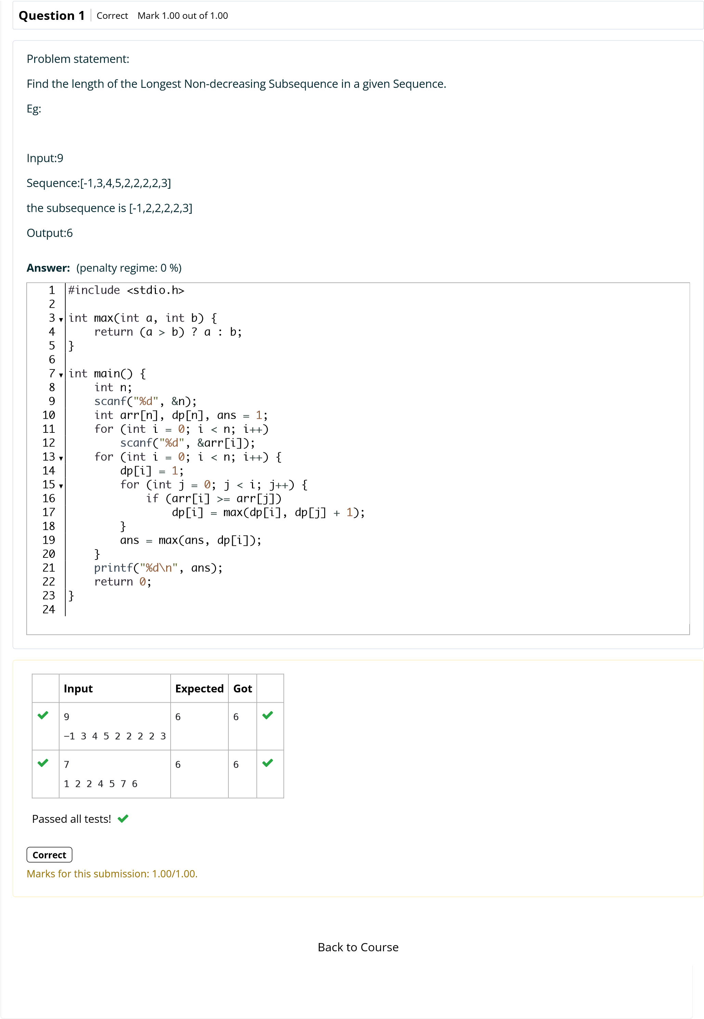

1. of 2



**N2**



6

**Started on**

Sunday, 12 October 2025, 11:23 AM

**State**

Finished

**Completed on**

Sunday, 12 October 2025, 11:27 AM

**Time taken**

4

mins 9 secs

**Marks**

1.00/1.00

**Grade**

**4.00**

out of 4.00 (

**100**

%)

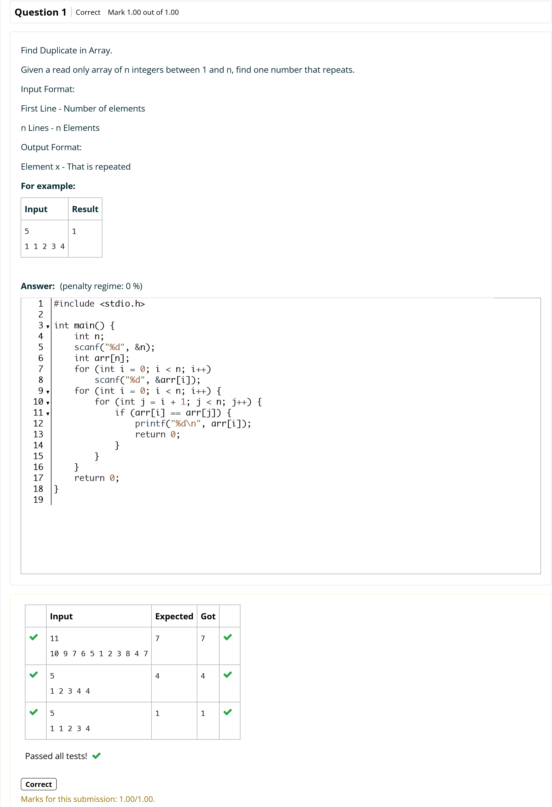

Back to Cour

[s](http://118.185.187.137/moodle/course/view.php?id=187)

[e](http://118.185.187.137/moodle/course/view.php?id=187)



**N2**



6

**Started on**

Sunday, 12 October 2025, 11:27 AM

**State**

Finished

**Completed on**

Sunday, 12 October 2025, 11:28 AM

**Time taken**

33

secs

**Marks**

1.00/1.00

**Grade**

**4.00**

out of 4.00 (

**100**

%)

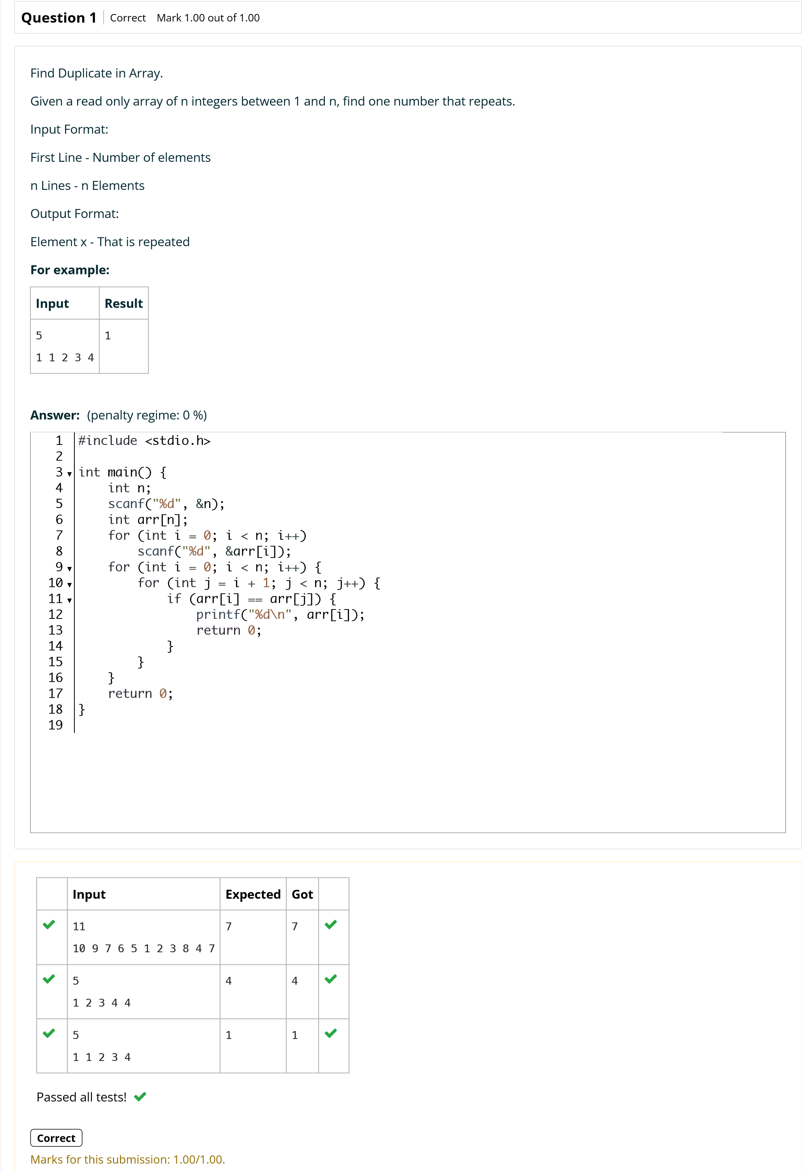

Back to Cour

[s](http://118.185.187.137/moodle/course/view.php?id=187)

[e](http://118.185.187.137/moodle/course/view.php?id=187)



**N2**



6

**Started on**

Sunday, 12 October 2025, 11:28 AM

**State**

Finished

**Completed on**

Sunday, 12 October 2025, 11:29 AM

**Time taken**

49

secs

**Marks**

1.00/1.00

**Grade**

**30.00**

out of 30.00 (

**100**

%)

**Question**

**1**

Correct

Mark 1.00 out of 1.00

Find the intersection of two sorted arrays.

OR in other words,

Given 2 sorted arrays, find all the elements which occur in both the arrays.

Input Format

·

The first line contains T, the number of test cases. Following T lines contain:

1.

Line 1 contains N1, followed by N1 integers of the first array

2.

Line 2 contains N2, followed by N2 integers of the second array

Output Format

The intersection of the arrays in a single line

Example

Input:

1

3

10 17

57

57 246

2 7 10 15

6

Output:

57

10

Input:

1

6

1 2 3 4 5

6

1

2

6

Output:

1

6

**For example:**

**Input**

**Result**

1

57

10 17

3

6

7 10 15

57 246

2

10

57

**Answer:**

)

penalty regime: 0 %

(

#include

<stdio.h>

int

main

(

)

{

int

T

;

scanf

(

"

%d

"

,

&

T

)

;

while

(

T

--

)

{

int

n1

,

n2

;

scanf

(

"

%d

"

,

&

n1

)

;

int

a

[

n1

]

;

for

(

int

i

=

0

;

i

<

n1

;

i

++

)

scanf

(

"

%d

"

,

&

a

[

i

])

;

scanf

(

"

%d

"

,

&

n2

)

;

int

b

[

n2

]

;

for

(

int

i

=

0

;

i

<

n2

;

i

++

)

scanf

(

"

%d

"

,

&

b

[

i

])

;



1

2

3

▼

4

5

6

▼

7

8

9

10

11

12

13

14

15

16

[s](http://118.185.187.137/moodle/course/view.php?id=187)

[e](http://118.185.187.137/moodle/course/view.php?id=187)

Back to Cour

**Input**

**Expected**

**Got**



1

3

10 17

57

6

2

7 10 15

57 246

10

57

10

57





1

6

1 2 3 4 5

6

2

1

6

6

1

1

6



Passed all tests!



**Correct**

Marks for this submission: 1.00/1.00.



**N2**



6

**Started on**

Sunday, 12 October 2025, 11:29 AM

**State**

Finished

**Completed on**

Sunday, 12 October 2025, 11:30 AM

**Time taken**

37

secs

**Marks**

1.00/1.00

**Grade**

**30.00**

out of 30.00 (

**100**

%)

**Question**

**1**

Correct

Mark 1.00 out of 1.00

Find the intersection of two sorted arrays.

OR in other words,

Given 2 sorted arrays, find all the elements which occur in both the arrays.

Input Format

·

The first line contains T, the number of test cases. Following T lines contain:

1.

Line 1 contains N1, followed by N1 integers of the first array

2.

Line 2 contains N2, followed by N2 integers of the second array

Output Format

The intersection of the arrays in a single line

Example

Input:

1

3

10 17

57

57 246

2 7 10 15

6

Output:

57

10

Input:

1

6

1 2 3 4 5

6

1

2

6

Output:

1

6

**For example:**

**Input**

**Result**

1

57

10 17

3

6

7 10 15

57 246

2

10

57

**Answer:**

)

penalty regime: 0 %

(

#include

<stdio.h>

int

main

(

)

{

int

T

;

scanf

(

"

%d

"

,

&

T

)

;

while

(

T

--

)

{

int

n1

,

n2

;

scanf

(

"

%d

"

,

&

n1

)

;

int

a

[

n1

]

;

for

(

int

i

=

0

;

i

<

n1

;

i

++

)

scanf

(

"

%d

"

,

&

a

[

i

])

;

scanf

(

"

%d

"

,

&

n2

)

;

int

b

[

n2

]

;

for

(

int

i

=

0

;

i

<

n2

;

i

++

)

scanf

(

"

%d

"

,

&

b

[

i

])

;



1

2

3

▼

4

5

6

▼

7

8

9

10

11

12

13

14

15

16

[s](http://118.185.187.137/moodle/course/view.php?id=187)

[e](http://118.185.187.137/moodle/course/view.php?id=187)

Back to Cour

**Input**

**Expected**

**Got**



1

3

10 17

57

6

2

7 10 15

57 246

10

57

10

57





1

6

1 2 3 4 5

6

2

1

6

6

1

1

6



Passed all tests!



**Correct**

Marks for this submission: 1.00/1.00.



**N2**



6

**Started on**

Sunday, 12 October 2025, 11:30 AM

**State**

Finished

**Completed on**

Sunday, 12 October 2025, 11:31 AM

**Time taken**

38

secs

**Marks**

1.00/1.00

**Grade**

**4.00**

out of 4.00 (

**100**

%)

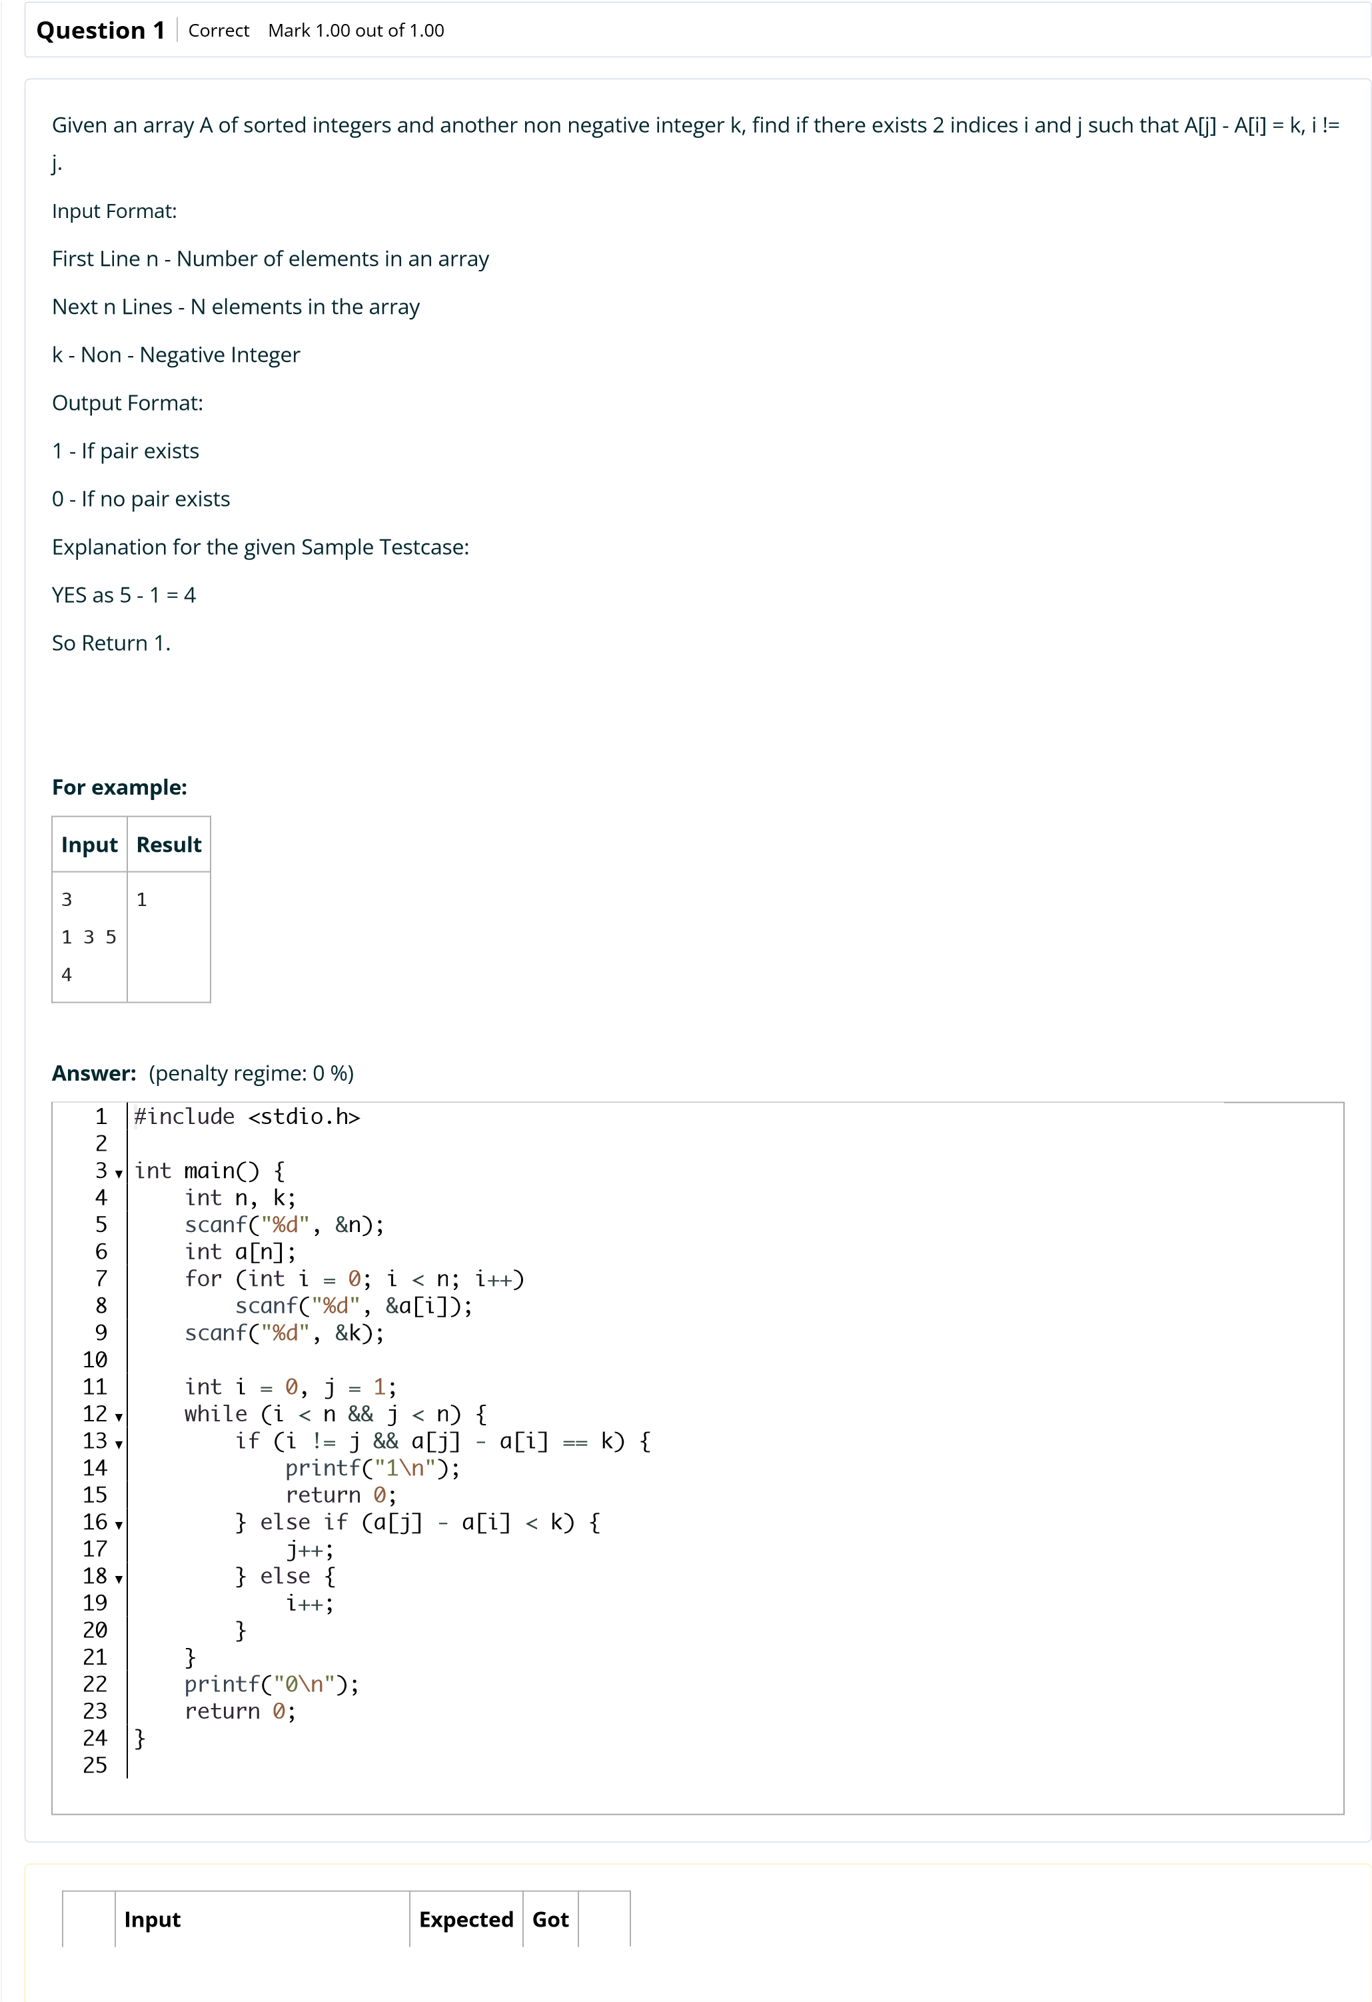

[s](http://118.185.187.137/moodle/course/view.php?id=187)

[e](http://118.185.187.137/moodle/course/view.php?id=187)

Back to Cour

**Input**

**Expected**

**Got**



3

1

3

5

4

1

1





10

1

4 6 8 12 14 15 20 21

25

1

1

1





10

1

2 3 5 11 14 16 24 28

29

0

0

0





10

0

2 3 7 13 14 15 20 24

25

10

1

1



Passed all tests!



**Correct**

Marks for this submission: 1.00/1.00.



**N2**



6

**Started on**

Sunday, 12 October 2025, 11:31 AM

**State**

Finished

**Completed on**

Sunday, 12 October 2025, 11:31 AM

**Time taken**

26

secs

**Marks**

1.00/1.00

**Grade**

**4.00**

out of 4.00 (

**100**

%)



[s](http://118.185.187.137/moodle/course/view.php?id=187)

[e](http://118.185.187.137/moodle/course/view.php?id=187)

Back to Cour

**Input**

**Expected**

**Got**



3

1

3

5

4

1

1





10

1

4 6 8 12 14 15 20 21

25

1

1

1





10

1

2 3 5 11 14 16 24 28

29

0

0

0





10

0

2 3 7 13 14 15 20 24

25

10

1

1



Passed all tests!



**Correct**

Marks for this submission: 1.00/1.00.